Sr. No. | Title | Page No.
1 | Abstract (Project Profile)  - Job Seeker  - Job Provider  - Client  - Administration  - Job Search | 3-4
2 | Introduction | 4-5
3 | Problem Definition And Feasibility Analysis  - Definition Of The Problem  - Existing System  - Proposed System  - Users Of The System  - Module Description
4 | System Analysis  - Hardware Requirements  - Software Requirements
5 | System Design  - Design Description  - Database Design  - Use Case Diagrams  - Sequence Diagrams  - Data Flow Diagrams:
6 | SOFTWARE TOOLS  Overview of java technology  About html  Introduction To servlets
7 | Testing And Implementation  Unit Testing  Integration Testing  Functional Testing  Acceptance Testing  Implementation
1.ABSTRACT

Job portal is developed for creating an interactive job vacancy for candidates. This web application is to be conceived in its current form as a dynamic site-requiring constant updates both from the seekers as well as the companies. On the whole the objective of the project is to enable jobseekers to place their resumes and companies to publish their vacancies. It enables jobseekers to post their resume, search for jobs, view personal job listings. It will provide various companies to place their vacancy profile on the site and also have an option to search candidate resumes. Apart from this there will be an admin module for the customer to make changes to the database content. It consists of 5 modules:
1. Job Seeker.
2. Job Provider.
3. Client.
4. Administrator.
5. Job Search.

  - Job Seeker:
This module contains details about Job Seeker, i.e. employee or un-employee details. Like employee name, email, experience ……. Here employee can do update, modify and delete. He can update experience and skills details also.
  - Job Provider:
This module having information about job provider and requirement details, which client recruiting the employees, and what based them recruiting the employees. Here client releasing the primary skills, experience, no. of vacancies, opening date, closing and closing date.
  - Client:
This module consisting details about the Clients, and Client profile.

  - Administrator:
The administrator module having all privileges about this entire project, he can update, delete, and modify the details about job seeker, job provider, client and Job Search details. Administrator maintain the client and job seeker database, where ever client is releasing their requirements( vacancies) with particular primary skills and experience, on that time administrator search for job seekers, who are having that primary skills and experience. Administrator sends the message for selected candidates.
  - Job Search:
This module having all current vacant jobs, experience and which client offering that vacant.

2. INTRODUCTION

About the project:

The actual problem is to create a website for the Consultant, is developed for creating an interactive job vacancy for candidates. This web application is to be conceived in its current form as a dynamic site-requiring constant updates both from the seekers as well as the companies. On the whole the objective of the project is to enable jobseekers to place their resumes and companies to publish their vacancies. It enables jobseekers to post their resume, search for jobs, view personal job listings. It will provide various companies to place their vacancy profile on the site and also have an option to search candidate resumes. Apart from this there will be an admin module for the customer to make changes to the database content. It consists of 5 modules:
The users of this system are searching for job, registration their personal, educational, skills, project and resume details. This system is designed such a way that the users can easily interact with the system with minimum knowledge to browser the net and company rules.
The Second chapter explains the exact Definition of the Problem and evolves out with the Feasibility Study of the product/part.
The Third chapter is System Analysis which deals about the Hardware and Software Specifications, and Software Requirement Specification, under this SRS Formal Description and Module Description.
The Fourth chapter describes the System Design, under this two levels of designs, they are
High level design (Data design, functional & interface design).
Low level design (Pseudo code & detail description of functions).
The Fifth chapter fully deals about Testing and Implementation of the whole project.
The Sixth chapter deals the Conclusion and Foreseeable Enhancements of the system.
The Seventh chapter deals about the Bibliography of this Project.
The Eight chapter is the final one which deals about the language used, tools used, Screen layouts and Reports.

3. PROBLEM DEFINITION AND FEASIBILITY ANALYSIS

3.1 Definition of the problem:

To create or develop a new system first we have to study the prior system, Analysis difficult problems faced by the operator of that system. System Analysis therefore understands such problems and proposes a new system in which the above problems are rectified.

3.2 Existing system:

Before creating this website, all jobseekers to send their resumes or information through postal mails or they use person to person contacts with each other. It will take long time to send their requirements through this type of communications.
Here there May error occurs in the process. The administration faces the problems to collect all the information from clients and consultants to analyze the requirement in the corresponding Clients. Administration has to send requirements information to different consultants and jobseekers.

3.3 Proposed System:

Here all job seekers send their resumes Or information through our site.It does not consume much of time.It is very easier to modify if any error occurs in the process.It is also very easier to administrator to collect information from clients and consultants.

3.4 Users of the system:

The users of this system are administrator, clients, job provider and jobseekers. This system is designed such a way that the users can easily interact with the system with minimum knowledge to browser the net and company rules.

3.5 Module Description:

The proposed system is developed by using five modules:

1. Job Seeker.
2. Job Provider.
3. Client.
4. Administrator.
5. Job Search.
3.5.1. Job Seeker:
This module contains details about Job Seeker, i.e. employee or un-employee details. Like employee name, email, experience.……. Here employee can do update, modify and delete. He can update experience and skills details also.
3.5.2. Job Provider:
This module having information about job provider and requirement details, which client recruiting the employees, and what based them recruiting the employees. Here client releasing the primary skills, experience, no. of vacancies, opening date, closing and closing date.
3.5.3. Client:
This module consisting details about the Clients, and Client profile.
3.5.4. Administrator:
The administrator module having all privileges about this entire project, he can update, delete, and modify the details about job seeker, job provider, client and Job Search details. Administrator maintain the client and job seeker database, where ever client is releasing their requirements( vacancies) with particular primary skills and experience, on that time administrator search for job seekers, who are having that primary skills and experience. Administrator sends the message for selected candidates.
3.5.5. Job Search:
This module having all current vacant jobs, experience and which client offering that vacant.

  - Module connectivity:

In the administrator module the administrator will be responsible for the registering the consultants and clients at the site. This module is also responsible for search for skilled applicants, shortlist the applicants and send the call letters to the applicants. In the jobseekers module the new user can registration their information, or existing jobseeker can update their information, search for job based on skills or experience.
The client module, different clients are fetching new job lists, and no. of vacates, opening date and closing date.

  - Feasibility study:

It is necessary and prudent to evaluate the feasibility of a project at the earliest possible time. There may be different ways of checking whether a system is feasible or not. The following feasibility studies were performed to gauge the feasibility of the system.

    - Operational Feasibility:

In this test, the operational scope of the system is checked. The system under consideration should have enough operational reach. It is observed that the proposed system is very user friendly and since the system is built with enough help, even persons with little knowledge of windows can find the system very easy.

    - Technical Feasibility:

This test includes a study of function, performance and constraints that may affect the ability to achieve an acceptable system. This test begins with an assessment of the technical viability of the proposed system. One of the main fusers to be accessed is the need of various kinds of resources for the successful implementation for the proposed system.

    - Economical Feasibility:

An evaluation of development cost weighed against the ultimate income or benefit derived from the development of the proposed system is made. Care must be taken that incurred in the development of the proposed of the system should not exceed from the system. The income can be in terms of money or goodwill, since the software brings in both, the system is highly viable.

SYSTEM ANALYSYS

4. SYSTEM ANALYSIS

Hardware and Software Specification:
The development of this project deals with the following environment
Hardware requirements
Software requirements
4.1 Hardware Requirements:
The selection of hardware is very important in the existence and proper working of any software. In the selection of hardware, the size and the capacity requirements are also important.
The job portal can be efficiently run on Pentium system with atleast 128MB RAM and Hard disk drive having 20GB. Floppy disk drive of 1.44MB and 14 inch Samsung color monitor suits the information system operation.(A Printer is required for hard copy output).
- Pentium processor -------- 233 MHZ or above
- RAM Capacity -------- 128MB
- Hard Disk -------- 20GB
- Floppy disk -------- 1.44MB
- CD-ROM Drive -------- 32HZ
- KEYBOARD -------- 108 Standard

4.2 Software Requirements:
One of the most difficult tasks is that, the selection of the software, once system requirement is known is determining whether a particular software package fits the requirements. After initial selection further security is needed to determine the desirability of particular software compared with other candidates. This section first summarizes the application requirement question and then suggests more detailed comparisons.

- Operating System -------- Windows 95/98/NT/2000
- Browser -------- IE, Mozilla.
- Web/Application Server -------- Tomcat 5.0
- Database Server -------- Oracle
- Database Connectivity -------- JDBC
- Other Tools & Technologies -------- Java (JDK), Servlets (JSDK), JSPl

.

SYSTEM DESIGN

5.system design

5.1 Design Description
Design is essentially a blue print or it acts as a bridge between the requirement specification and the final solution for satisfying the requirements.
Based on the work-flow described above we can draw the following conclusions for the
Software System that has to be developed:
- The System needs to be a web-based system so that it allows the consultants,
clients & jobseekers to access the company database over the Internet.
- Being a web-based system also enables the Company staff to send e-mails immediately
to Suppliers, whenever a requirement for Parts arises.
- An added advantage is since the e-mail is delivered instantly, there could be instant
responses from the Jobseekers.
- The whole process depends on communications between jobseekers & the
Administrators, different clients & the consol tents. If all these communications are
done through a web-based system, then the time period for the whole process can
be considerably brought down.
- The System needs to store the details of all the jobseekers.
- The System needs to store the details of all the information(personal ,education,
skills , experience, projects etc) held by all the Jobseekers.
- The System needs to store the details of all the requirements held in the different clients.
- The System needs to store the details of all the jobs held in the Consultants.
- The System needs to store the details of all the Consultants.
- Since it is a web-based system, a Login authorization should be provided so that
Consultants, jobseekers, and clients will be able to lookup & use options that are
specific to them.
- The System should allow the Clients to enter their Requirements.
- The System should allow the Consultant to provide for jobs for jobseekers.
- The System should provide an option to generate a client Report.
- The System should provide an option to generate a consultants Report.
- The System should provide an option to short list applicants Report.
- The System should provide an option to generate selected applicants Report.

5.2 DataBase design:

5.2.1 Table Name:employee_contact:

Description: This table is used for entered new jobprovider‘s information.

SL.NO | FIELD NAME | DATA TYPE | DESCRIPTION
1 | EMPID | Number | This is unique identifier given to a  job providers to identify him uniquely. This is the Primary Key of the table.
2 | EMP_NAME | Varchar2(100) | This is the name of the jobproviders
3 | EMP_DESG | Varchar2(80) | This is the designation of the jobproviders
4 | EMP_NUMBER | Number | This is the Middle name of the jobseekers
5 | EMP_CMPNYNAME | Varchar2(20) | This is the Last name of the jobseekers
6 | EMP_CMPNYADD | Varchar2(100) | This is the address of the jobproviders
7 | EMP_CMPNYSTATE | Varchar2(100) | This is the state of the jobproviders  Company
8 | EMP_CMPNYCITY | Varchar2(30) | This is the city of the jobproviders company
9 | EMP_CMPNYPROFILE | Varchar2(30) | This is the profile of the jobproviders company
10 | EMP_CMPNYWEBSITE | Varchar2(30) | This is the website of the jobproviders company

5.2.2Table Name: FAQS :
Description: This table is used for entering FAQS information

SL.NO | FIELD NAME | DATA TYPE | DESCRIPTION
1 | FAQID | Number | This identifier given to a FAQ
2 | QUESTION | Varchar2(2000) | This the question entered
3 | ANSWER | Varchar2(4000) | This is the answer for the question

5.2.3 Table Name: ADMINARTICLES:
Description: This table is used for entered ADMINARTICLES information

SL.NO | FIELD NAME | DATA TYPE | DESCRIPTION
1 | ARTICLEID | Number | This is identifier given to a article
2 | ARTICLENAME | Varchar2(200) | This the Name of the ARTICLE
3 | POSTEDON | Varchar2(200) | This the date when article posted
4 | ARTICLEDESC | Varchar2(200) | This the description of article

5.2.4 Table Name: ADMIN DETAILS:
Description: This table is used for entered administrator details

SL.NO | FIELD NAME | DATA TYPE | DESCRIPTION
1 | ADMINID | Number | This is unique identifier given to a  Administrator to identify him uniquely.  This is the Primary Key of the table.
2 | USRNAME | Varchar2(20) | This the user name for administrator
3 | PASSWORD | Varchar2(20) | This the password for administrator.

5.2.5 Table Name: JOB PROFILE:
Description: This table provides information about the details of the job.

SL.NO | FIELD NAME | DATA TYPE | DESCRIPTION
1 | EMPID | Number | This is unique identifier given to a User to  identify him uniquely. This is the Primary Key of the table
2 | JOBCODE | Varchar2(20) | This is the code of job.
3 | JOBTITLE | Varchar2(15) | This is the title of job.
4 | JOBREQ | Varchar2(15) | This is the requirements of job.
5 | LOCATION | Varchar2(20) | This is the location of placement for job.
6 | SKILLSET | Varchar2(20) | This is the skill set required for the job.
7 | POSTDATE | Varchar2(20) | This is the post date of job.
8 | EXPIRY DATE | Varchar2(20) | This is the expiry date for job.
9 | CONTACT INFO | Varchar2(20) | This is the contact information of company.

5.2.6 Table Name:EMPLOYEE_USERANDPSWD:
Description: This table is used for the maintenance details of employee userid and password

SL.NO | FIELD NAME | DATA TYPE | DESCRIPTION
1 | EMPID | Varchar2(20) | This is userid
2 | USERNAME | Varchar2(20) | This is the username.
3 | PASSWORD | Varchar2(20) | This is the password

5.2.6 Table Name:EMPLOYEE_USERANDPSWD:
Description: This table is used for the maintenance details of employee userid and password

SL.NO | FIELD NAME | DATA TYPE | DESCRIPTION
1 | EMPID | Varchar2(20) | This is userid
2 | USERNAME | Varchar2(20) | This is the username.
3 | PASSWORD | Varchar2(20) | This is the password

5.2.7 Table Name:CONSULTANCY:
Description: This table is used to maintain the details of consultant.

SL.NO | FIELD NAME | DATA TYPE | DESCRIPTION
1 | CUSERID | Varchar2(20) | This is consultant id.
2 | PASSWORD | Varchar2(20) | This is the password.

5.2.8 Table Name: JOBSEEKER:
Description: This table is used to maintain the details of the jobseeker.

SL.NO | FIELD NAME | DATA TYPE | DESCRIPTION
1 | JSID | Number(10) | This is unique identifier given to a User to  identify him uniquely. This is the Primary Key of the table.
2 | EMAILID | Varchar2(20) | This is the EMAILID of the jobseeker.
3 | PASSWORD | Varchar2(20) | This is the password of the jobseeker.
4 | MOBILENO | Number(10) | This is the mobileno of the jobseeker.
5 | CITYPIN | Number(10) | This is the pinno of jobseeker city.
6 | ADDRESS | Varchar2(70) | This is the address of the jobseeker.
7 | PASSPORTNO | Varchar2(20) | This is the passport number of jobseeker.
8 | GENDER | Varchar2(2) | This is the gender of the jobseeker.
9 | SKILLS | Varchar2(200) | This is about the personal skills of the  Jobseeker.
10 | EXP | Varchar2(200) | This is about the experience of the jobseeker.
11 | RESUME | BLOB | This is the resume of the jobseeker.

5.2.9 Table Name:JOBSEEKER_USERANDPSWD:
Description: This is about the jobseeker user and password details.

SL.NO | FIELD NAME | DATA TYPE | DESCRIPTION
1 | JSID | Varchar2(20) | This is about the jobseeker ID.
2 | EMAILID | Varchar2(20) | This is the emailid of the Jobseeker.
3 | PASSWORD | Varchar2(20) | This is the password of the jobseeker.

5.3 Use case diagrams:

5.3.1 JOB SEEKER:
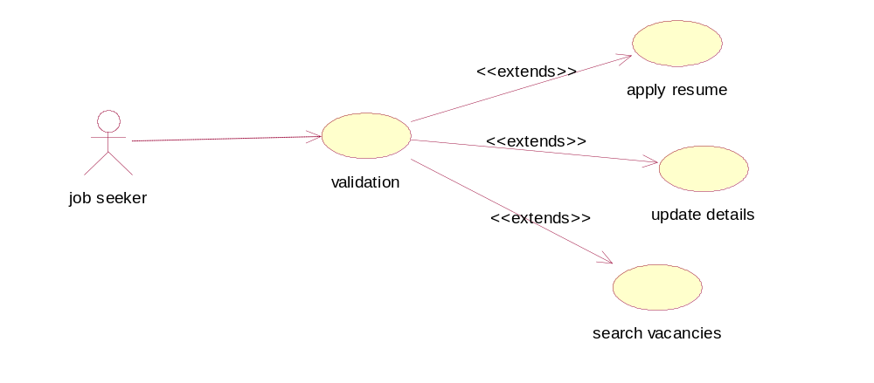

5.3.2 ADMINISTRATOR:

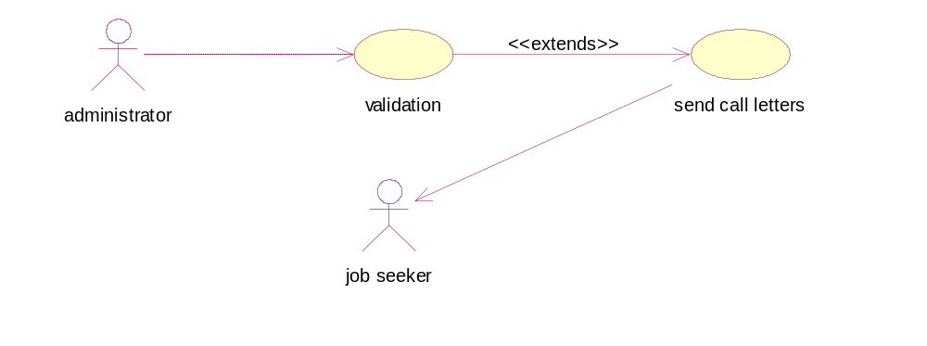

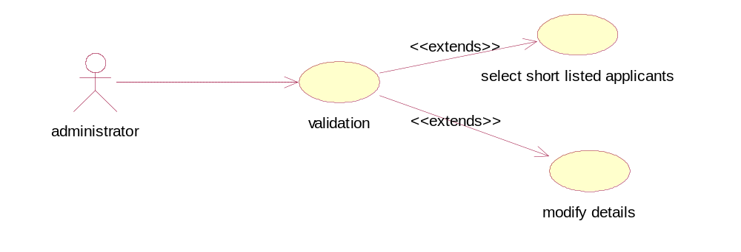

5.3.3 CLIENT:

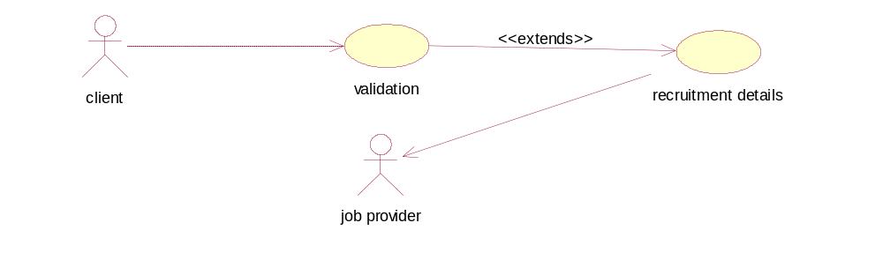

5.3.4 JOB PROVIDER:

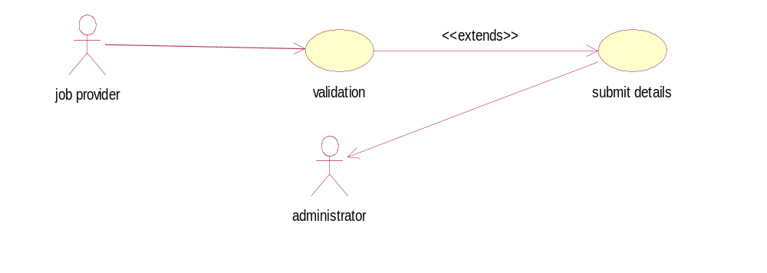

5.4 Sequence Diagrams:

5.4.1 JOB SEEKER:

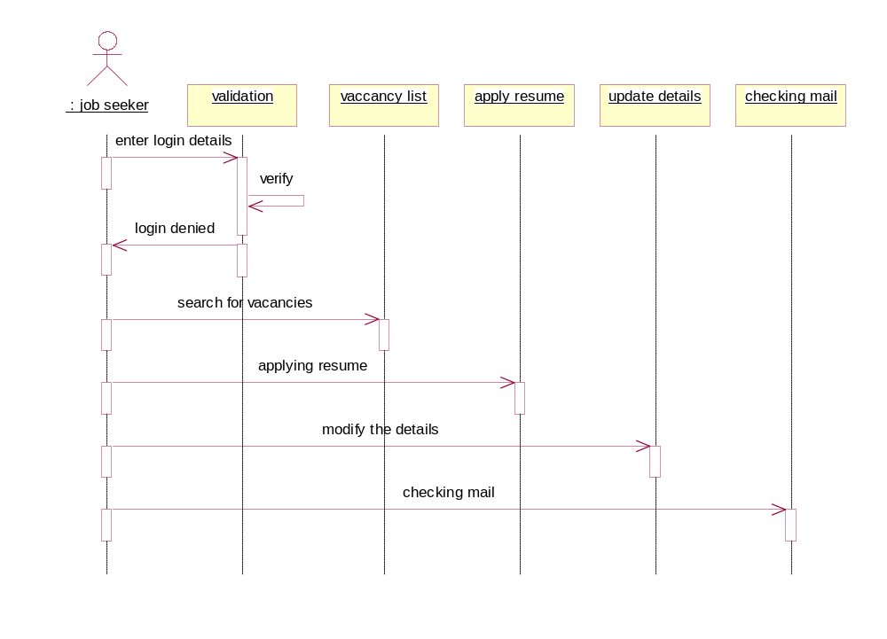

5.4.2 JOB PROVIDER:

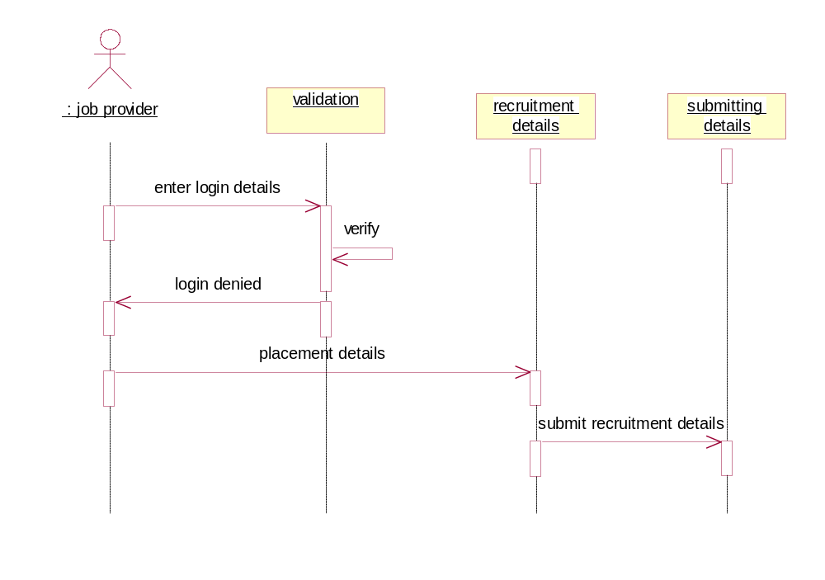

5.4.3 CLIENT:

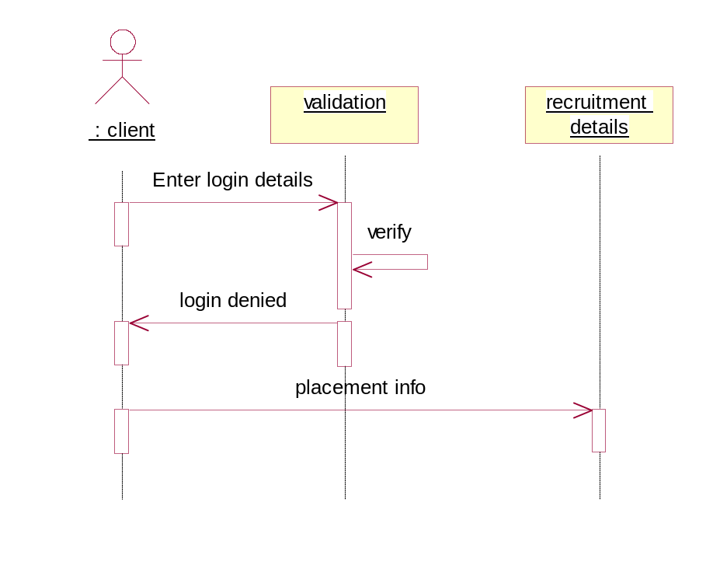

5.4.4 ADMINISTRATOR:

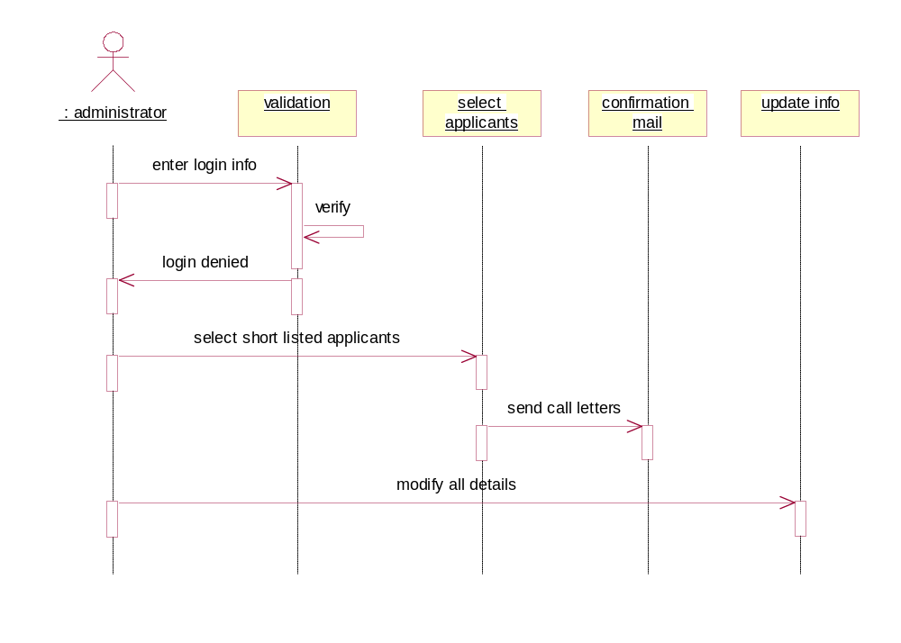

5.5 DATA FLOW DIAGRAMS:

NOTATIONS :
The logic dataflow diagrams can be drawn using only four simple notations i.e., special Symbols or icons and the annotation that associates them with a specific system. Since the choice of notation we follow, does not affect impede or catalyze the system process; we used three symbols from YOURON notation and one from Gain and Sarson notation as specified below.
Element References symbols

Data Flow Process

Process

Data Store

Source or Sink

Description:
Process : Describes how input data is converted to output Data
Data Store : Describes the repositories of data in a system
Data Flow : Describes the data flowing between process, Data stores and
external entities.
Sources : An external entity causing the origin of data.
Sink : An external entity, which consumes the data.

5.5.1 Context level:
0 level:

JOB PORTAL
Administrator
Job Seeker
Consol tenet
Client
Client
Consol tenet
Job Seeker
Administrator

administrator

Login database

Ex-Job Seeker
Login
process
Users
Consultant

Ex-Client
registration

Level 1 Diagrams:

ADMINISTRATOR:

Client

Job portal
Consultant
Jobseeker
Job search
Administrator

Short listed students

JOB SEEKER:
Job seeker
Job portal
Add new job seeker details
update
delete

CLIENT:

update
Job portal
Add new Client details
delete
Add new Jobs
Client

JOB PROVIDER:

Update jobs
Job portal
Consultant

Delete jobs

- SOFTWARE TOOLS

6.1 OVERVIEW OF JAVA TECHNOLOGY

6.1.1 HISTORY OF JAVA
Java language was developed by James Gosling and his team at sun micro systems and released formally in 1995. Its former name is oak. Java Development Kit 1.0 was released in 1996. to popularize java and is freely available on Internet.
Java is loosely based on C++ syntax, and is meant to be Object-Oriented Structure of java is midway between an interpreted and a compiled language . java programs are compiled by the java compiler into byte codes which are secure and portable across different platforms . These byte codes are essentially instructions encapsulated in single type, to what is known as java virtual machine (JVM) which resides instandard browser.
JVM verifies these byte codes when downloaded by the browser for integrity. Java Virtual Machines available for almost all Operating Systems. JVM converts these byte codes into machine specific instructions at runtime.

6.1.2 FEATURES OF JAVA
- Java is object-oriented language and supports encapsulation, inheritance , polymorphism and dynamic binding , but does not support multiple inheritance.every thing in java is an object except some primitive datatypes .
- Java is portable architecture neutral that is java programs once compiled can be executed on any machine that is enabled.
- Java is distributed in its approach and used for internet programming.
- Java is robust, secured, high performing and dynamic in nature.
- Java supports multithreading. There for different parts of the program can be executed at the same time

6.1.3 JAVA AND INTERNET
Java is strongly associated with internet and known as internet programming language. Internet users can use java to create applet programs and run them locally using java enabled browser search as hot java. Applets can be downloaded from remote machine via internet and run it on local machine .

6.1.4 JAVA AND WORLD WIDE WEB

World wide web is an open ended information retrieval system designed to be used in the distributed environment. This system contains web pages that provide both information and controls. We can navigate to a new web page in any direction. This is made possible worth HTML java was meant to be used in distributed environment such as internet. So java could be easily incorporated into the web system and is capable of supporting animation graphics , games and other special effect. The web has become more dynamic and interactive with support of java. We can run a java program on remote machine over internet with the support of web .

6.1.5 JAVA ENVIRONMENT
Java environment includes a large no.of tools which are part of the system known as java development kit (JDK) and hundreds of classes, methods, and interfaces grouped into packages forms part of java standard library(JSL).

6.1.6 JAVA ARCHITECTURE
Java architecture provides a portable , robust , high performing environment for development. Java provides portability by compiling the byte codes for the java virtual machine which are then interpreted on each platform by the runtime environment . Java also provides stringent compile and runtime checking and automatic memory management in order to ensure solid code .

6.1.7 JAVA VIRTUAL MACHINE
When we compile the code, java compiler creates machine code (byte code) for a hypothetical machine called java virtual machine (JVM). The JVM will execute the byte code and overcomes the issue of portability .The code is written and compile for one machine and interpreted all other machines. This machine is called java virtual machine. .

6.1.8 PARADIGM OF JAVA
- Dynamic down loading applets(small application programs);
- Elimination of flatware phenomenon that is providing those features of a product that user needs at a time. The remaining features of a product can remain in the server.
- Changing economic model of the software
- Up-to-date software availability
- Supports network entire computing

6.2 ABOUT HTML
HTML (hyper text markup language) is a language used to create hyper text documents that have hyper links embedded in them . it consists of tags embedded in the text of a document with HTML. We can build web pages or web document s. it is basically a formatting language and not a programming language. The browser reading the document interprets mark up tags to help format the document for subsequent display to a reader. HTML is a language for describing structured documents. HTML is a platform independent. WWW(world wide web) pages are written using HTML. HTML tags control in part the representation of the WWW page when view with web browser. The browser interprets HTML tags in the web document and displays it. Different browsers show data differently. Examples of browsers used to be web pages include:
- Netscape
- Internet Explorer

JAVA SCRIPT
Java script is a general purpose prototype based , object oriented scripting language developed jointly by sun and Netscape and is meant for the WWW . it is designed to be embedded in diverse applications and systems , with out consuming much memory . java script borrows most of its syntax from java but also inherits from AWK and PERL , with some indirect influence from self in its object prototype system.
Java scripts dynamically typed that is programs do not declare variable types, and the type of variable is unrestricted and can change at runtime. source can be generated at run time and evaluated against an arbitrary scope. Typical implementations compile by translating source into a specified byte code format, to check syntax and source consistency. Note that the availability to generate and interpret programs at runtime implies the presence of a compiler at runtime.
Java script is a high level scripting language that does not depend on or expose particular machine representations or operating system services. It provides automatic storage management, typically using a garbage collector.

FEATURES:
- Java script is embedded into HTML documents and is executed with in them.
- Java script is browser dependent
- Java script is an interpreted language that can be interpreted by the browser at run time .
- Java script is loosely typed language
- Java script is an object based language.
- Java script is an Event-Driven language and supports event handlers to specify the functionality of a button.
ADVANTAGES
  - Java script can be used for client side application
  - Java script provides means to contain multi frame windows for presentation of the web.
  - Java script provides basic data validation before it is sent to the server. EG : login and password checking or whether the values entered are correct or whether all fields in a from are filled and reduced network traffic
  - It creates interactive forms and client side lookup tables .

6.3 Introduction to SERVLETS

servlets provide a Java^{(TM)}-based solution used to address the problems currently

assosciated with doing server-side programming, including inextensible scripting solutions, platform-specific APIs, and incomplete interfaces.
servlets are objects that conform to a specific interface that can be plugged into a Java-based server. Servlets are to the server-side what applets are to the client-side -- object byte codes that can be dynamically loaded off the net. They differ from applets in that they are faceless objects (without graphics or a GUI component). They serve as platform-independent, dynamically-loadable, pluggable helper byte code objects on the server side that can be used to dynamically extend server-side functionality.
What is a SERVLET?
servlets are modules that extend request/response-oriented servers, such as Java-enabled web servers. For example, a SERVLET might be responsible for taking data in an HTML order-entry form and applying the business logic used to update a company's order database
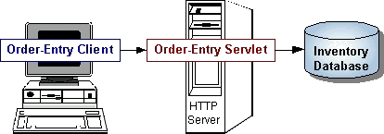

servlets are to servers what applets are to browsers. Unlike applets, however, servlets have no graphical user interface.
servlets can be embedded in many different servers because the servlet API, which you use to write servlets, assumes nothing about the server's environment or protocol. Servlets have become most widely used within HTTP servers; many web servers support the Servlet API.
Use SERVLETS instead of CGI Scripts!
SERVLETS are an effective replacement for CGI scripts. They provide a way to generate dynamic documents that is both easier to write and faster to run. Servlets also address the problem of doing server-side programming with platform-specific APIs: they are developed with the Java Servlet API, a standard Java extension.
So use SERVLETS to handle HTTP client requests. For example, have servlets process data posted over HTTPS using an HTML form, including purchase order or credit card data. A servlet like this could be part of an order-entry and processing system, working with product and inventory databases, and perhaps an on-line payment system.

Other Uses for Servlets
Here are a few more of the many applications for servlets:
- Allowing collaboration between people. A servlet can handle multiple requests concurrently, and can synchronize requests. This allows servlets to support systems such as on-line conferencing.
- Forwarding requests. Servlets can forward requests to other servers and servlets. Thus servlets can be used to balance load among several servers that mirror the same content, and to partition a single logical service over several servers, according to task type or organizational boundaries.
Architecture of the Servlet Package
The javax.servlet package provides interfaces and classes for writing servlets. The architecture of the package is described below.
The SERVLET Interface
The central abstraction in the Servlet API is the Servlet interface. All servlets implement this interface, either directly or, more commonly, by extending a class that implements it such as HTTPSERVLET.

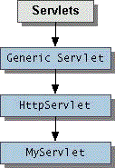
The Servlet interface declares, but does not implement, methods that manage the servlet and its communications with clients. Servlet writers provide some or all of these methods when developing a servlet.
Client Interaction
When a servlet accepts a call from a client, it receives two objects:
- A SERVLETREQUEST, which encapsulates the communication from the client to the server.
- A SERVLETRESPONSE, which encapsulates the communication from the servlet back to the client.
SERVLETREQUEST and SERVLETRESPONSE are interfaces defined by the JAVAX.SERVLET package.
The SERVLETREQUEST Interface
The SERVLETREQUEST interface allows the servlet access to:
- Information such as the names of the parameters passed in by the client, the protocol (scheme) being used by the client, and the names of the remote host that made the request and the server that received it.
The input stream, SERVLETINPUTSTREAM. SERVLETS use the input stream to get data from clients that use application protocols such as the HTTP POST and PUT methods.
Interfaces that extend SERVLETREQUEST interface allow the servlet to retrieve more protocol-specific data. For example, the HTTPSERVLETREQUEST interface contains methods for accessing HTTP-specific header information.
The SERVLETRESPONSE Interface
The SERVLETRESPONSE interface gives the servlet methods for replying to the client. It:
- Allows the servlet to set the content length and MIME type of the reply.
- Provides an output stream, SERVLETOUTPUTSTREAM, and a Writer through which the servlet can send the reply data.
Interfaces that extend the SERVLETRESPONSE interface give the servlet more protocol-specific capabilities. For example, the HTTPSERVLETRESPONSE interface contains methods that allow the servlet to manipulate HTTP-specific header information.
Additional Capabilities of HTTP Servlets
The classes and interfaces described above make up a basic Servlet. HTTP servlets have some additional objects that provide session-tracking capabilities. The servlet writer can use these APIs to maintain state between the servlet and the client that persists across multiple connections during some time period. HTTP servlets also have objects that provide cookies. The servlet writer uses the cookie API to save data with the client and to retrieve this data.

The classes mentioned in the Architecture of the Servlet Package section are shown in the example in bold:
- SIMPLESERVLET extends the HTTPSERVLET class, which implements the Servlet interface.
- Simple SERVLET overrides the do Get method in the HTTPSERVLET class. The do Get method is called when a client makes a GET request (the default HTTP request method), and results in the simple HTML page being returned to the client.
- Within the do Get method,
The user's request is represented by an HTTPSERVLETREQUEST object.
- The response to the user is represented by an HTTPSERVLETRESPONSE object.
- Because text data is returned to the client, the reply is sent using the Writer object obtained from the HTTPSERVLETRESPONSE object.

SERVLET Lifecycle
Each servlet has the same life cycle:
- A server loads and initializes the servlet
- The SERVLET handles zero or more client requests
- The server removes the servlet

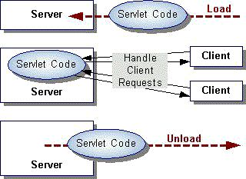
Initializing a SERVLET
When a server loads a servlet, the server runs the servlet's init method. Initialization completes before client requests are handled and before the servlet is destroyed.
Even though most servlets are run in multi-threaded servers, servlets have no concurrency issues during servlet initialization. The server calls the init method once, when the server loads the servlet, and will not call the init method again unless the server is reloading the servlet.
The server can not reload a servlet until after the server has destroyed the SERVLET by calling the destroy method.
The init Method
The init method provided by the httpservlet class initializes the servlet and logs the initialization. To do initialization specific to your servlet, override the init() method following these rules:
- If an initialization error occurs that renders the servlet incapable of handling client requests, throw an Unavailable exception.
- An example of this type of error is the inability to establish a required network connection.
- Do not call the system.exit method

Initialization Parameters
The second version of the init method calls the GETINITPARAMETER method. This method takes the parameter name as an argument and returns a String representation of the parameter's value.
The specification of initialization parameters is server-specific. In the Java Web Server, the parameters are specified with a servlet is added then configured in the Administration Tool. For an explanation of the Administration screen where this setup is performed, see the Administration Tool: Adding Servlets online help document. If, for some reason, you need to get the parameter names, use the getparameternames method.
Destroying a SERVLET
servlets run until the server are destroys them, for example at the request of a system administrator. When a server destroys a servlet, the server runs the servlet's destroy method. The method is run once; the server will not run that servlet again until after the server reloads and reinitializes the servlet.
When the destroy method runs, another thread might be running a service request. The Handling Service Threads at Servlet Termination section shows you how to provide a clean shutdown when there could be long-running threads still running servicerequests.

Using the Destroy Method
The destroy method provided by the httpservlet class destroys the servlet and logs the destruction. To destroy any resources specific to your servlet, override the destroy method. The destroy method should undo any initialization work and synchronize persistent state with the current in-memory state.
The following example shows the destroy method that accompanies the init method shown previously:
Public class BOOKDBSERVLET extends GENERICSERVLET {
Private BOOKSTORE DB books;
... // the init method
Public void destroy() {
// Allow the database to be garbage collected
books = null;
}
}

A server calls the destroy method after all service calls have been completed, or a server-specific number of seconds have passed, whichever comes first. If your servlet handles any long-running operations, service methods might still be running when the server calls the destroy method. You are responsible for making sure those threads complete. The next section shows you how.
The destroy method shown above expects all client interactions to be completed when the destroy method is called, because the servlet has no long-running operations.

Handling Service Threads at Servlet Termination
All of a SERVLET'S service methods should be complete when a servlet is removed. The server tries to ensure this by calling the destroy method only after all service requests have returned, or after a server-specific grace period, whichever comes first. If your servlet has operations that take a long time to run (that is, operations that may run longer than the server's grace period), the operations could still be running when destroy is called. You must make sure that any threads still handling client requests complete; the remainder of this section describes a technique for doing this.
If your servlet has potentially long-running service requests, use the following techniques to:
- Keep track of how many threads are currently running the service method.
- Provide a clean shutdown by having the destroy method notify long-running threads of the shutdown and wait for them to complete
- Have the long-running methods poll periodically to check for shutdown and, if necessary, stop working, clean up and return.

Tracking Service Requests
To track service requests, include a field in your servlet class that counts the number of service methods that are running. The field should have access methods to increment, decrement, and return its value.
The service method should increment the service counter each time the method is entered and decrement the counter each time the method returns. This is one of the few times that your httpservlet subclass should override the service method. The new method should call super.service to preserve all the original httpservlet.service method's functionality.

Providing a Clean Shutdown
To provide a clean shutdown, your destroy method should not destroy any shared resources until all the service requests have completed. One part of doing this is to check the service counter. Another part is to notify the long-running methods that it is time to shut down. For this, another field is required along with the usual access methods.
Creating Polite Long-running Methods

The final step in providing a clean shutdown is to make any long-running methods behave politely. Methods that might run for a long time should check the value of the field that notifies them of shutdowns,and interrupt their work if necessary.

Servlet-client Interaction

Handling HTTP Clients
An HTTP Servlet handles client requests through its service method. The service method supports standard HTTP client requests by dispatching each request to a method designed to handle that request. For example, the service method calls the do Get method shown earlier in the simple example servlet.
Requests and Responses:
Methods in the HTTPSERVLET class that handle client requests take two arguments:
- An HTTPSERVLETREQUEST object, which encapsulates the data from the client
- An HTTPSERVLETRESPONSE object, which encapsulates the response to the client

HTTPSERVLETREQUEST Objects
An HTTPSERVLETREQUEST object provides access to HTTP header data, such as any cookies found in the request and the HTTP method with which the request was made. The HTTPSERVLETREQUEST object also allows you to obtain the arguments that the client sent as part of the request.

To access client data:
- The GETPARAMETER method returns the value of a named parameter. If your parameter could have more than one value, use GETPARAMETERVALUES instead. The GETPARAMETERVALUES method returns an array of values for the named parameter. (The method GETPARAMETERNAMES provides the names of the parameters.)
- For HTTP GET requests, the GETQUERYSTRING method returns a String of raw data from the client. You must parse this data yourself to obtain the parameters and values.
- For HTTP POST, PUT, and DELETE requests,
  - If you expect text data, the GETREADER method returns a BUFFEREDREADER for you to use to read the raw data.
  - If you expect binary data, the GETINPUTSTREAM method returns a SERVLETINPUTSTREAM for you to use to read the raw data

Note: Use either a GET PARAMETER[Values] method or one of the methods that allow you to parse the data yourself. They can not be used together in a single request.

HTTPSERVLETRESPONSE Objects
An HTTPSERVLETRESPONSE object provides two ways of returning data to the user:
- The GETWRITER method returns a Writer
- The GETOUTPUTSTREAM method returns a SERVLETOUTPUTSTREAM
Use the GETWRITER method to return text data to the user, and the GETOUTPUTSTREAM method for binary data. Closing the Writer or SERVLETOUTPUTSTREAM after you send the response allows the server to know when the response is complete. .

HTTP Header Data
You must set HTTP header data before you access the Writer or OUTPUTSTREAM. The HTTPSERVLETRESPONSE class provides methods to access the header data. For example, the SETCONTENTTYPE method sets the content type. (This header is often the only one manually set.)
Handling GET and POST Requests
The methods to which the service method delegates HTTP requests include,
- DOGET, for handling GET, conditional GET, and HEAD requests
- DOPOST, for handling POST requests
- DOPUT, for handling PUT requests
- DODELETE, for handling DELETE requests
By default, these methods return a BAD_REQUEST (400) error. Your servlet should override the method or methods designed to handle the HTTP interactions that it supports. This section shows you how to implement methods that handle the most common HTTP requests: GET and POST.
The HTTPSERVLET'S service method also calls the DOOPTIONS method when the servlet receives an OPTIONS request, and DOTRACE when the servlet receives a TRACE request. The default implementation of do Options automatically determines what HTTP options are supported and returns that information. The default implementation of DOTRACE causes a response with a message containing all of the headers sent in the trace request. These methods are not typically overridden.
Servlet Descriptions
In addition to handling HTTP client requests, some applications, such as the Java Web Server's Administration Tool, get descriptive information from the servlet and display it. The servlet description is a string that can describe the purpose of the servlet, its author, its version number, or whatever the servlet author deems important.
The method that returns this information is GETSERVLETINFO, which returns null by default. You are not required to override this method, but applications are unable to supply a description of your servlet unless you do.

Writing Your First Servlet
Servlets are also easy to develop. This document discusses the following minimum steps needed to create any servlet:
- Write the servlet
  - Import the necessary Java packages
  - Inherit from GENERICSERVLET or the HTTP convenience class HTTPSERVLET
  - Override the service method (this is where the actual work is done by the servlet)
  - Save the file with a .java filename extension
- Compile the servlet
  - Make sure jws.jar is included in your class path
  - Invoke javac
- Install the servlet
  - Use the Java Web Server's Administration Tool to install it, and optionally configure it.
- Test the servlet
  - Invoke the servlet from a JDK1.1-compatible browser.

About Session Tracking
Session T tracking is a flexible, lightweight mechanism that enables STATEFUL programming on the web. Its general implementation serves as a basis for more sophisticated state models, such as persistent user profiles or multi-user sessions.
A session is a series of requests from the same user that occur during a time period. This transaction model for sessions has many benefits over the single-hit model. It can maintain state and user identity across multiple page requests. It can also construct a complex overview of user behavior that goes beyond reporting of user hits.

Server-Side Session Objects and Users
Session tracking gives servlets and other server-side applications the ability to keep state information about a user as the user moves through the site. Server-side applications can use this facility to create more STATEFUL user experiences and to track who's doing what on the site.
Java Web Server maintains user state by creating a Session object for each user on the site. These Session objects are stored and maintained on the server. When a user first makes a request to a site, the user is assigned a new Session object and a unique session ID. The session ID matches the user with the Session object in subsequent requests. The Session object is then passed as part of the request to the servlets that handle the request. Servlets can add information to Session objects or read information from them.

Session Endurance
After the user has been idle for more than a certain period of time (30 minutes by default), the user's session becomes invalid, and the corresponding Session object is destroyed.
A session is a set of requests originating from the same browser, going to the same server, bounded by a period of time. Loosely speaking, a session corresponds to a single sitting of a single anonymous user (anonymous because no explicit login or authentication is required to participate in session tracking).
The first part of the DOGET method associates the Session object with the user making the request. The second part of the method gets an integer data value from the Session object and increments it. The third part outputs the page, including the current value of the counter.
When run, this servlet should output the value of the counter that increments every time you reload the page. You must obtain the Session object before you actually write any data to the SERVLET'S output stream. This guarantees that the session tracking headers are sent with the response.
The Session object has methods similar to JAVA.UTIL.DICTIONARY for adding, retrieving, and removing arbitrary Java objects. In this example, an Integer object is read from the Session object, incremented, then written back to the Session object.
Any name, such as sessiontest.counter, may be used to identify values in the Session object. When choosing names, remember that the Session object is shared among any servlets that the user might access. Servlets may access or overwrite each other's values from the Session. Thus, it is good practice to adopt a convention for organizing the namespace to avoid collisions between servlets, such as: servletname.name

Session Invalidation
Sessions can be invalidated automatically or manually. Session objects that have no page requests for a period of time (30 minutes by default) are automatically invalidated by the Session Tracker SESSIONINVALIDATIONTIME parameter. When a session is invalidated, the Session object and its contained data values are removed from the system.
After invalidation, if the user attempts another request, the Session Tracker detects that the user's session was invalidated and creates a new Session object. However, data from the user's previous session will be lost.
Session objects can be invalidated manually by calling session.invalidate(). This will cause the session to be invalidated immediately, removing it and its data values from the system.

Handling Non-Cookie Browsers (URL Rewriting)
The Session Tracker uses a session ID to match users with Session objects on the server side. The session ID is a string that is sent as a cookie to the browser when the user first accesses the server. On subsequent requests, the browser sends the session ID back as a cookie, and the server uses this cookie to find the session associated with that request.
There are situations, however, where cookies will not work. Some browsers, for example, do not support cookies. Other browsers allow the user to disable cookie support. In such cases, the Session Tracker must resort to a second method, URL rewriting, to track the user's session.
URL rewriting involves finding all links that will be written back to the browser, and rewriting them to include the session ID. For example, a link that looks like this:
<a HREF="/store/catalog">
might be rewritten to look like this:
<a HREF="/store/catalog;$sessionid$DA32242SSGE2">
If the user clicks on the link, the rewritten form of the URL will be sent to the server. The server's Session Tracker will be able to recognize the ;$sessionid$DA32242SSGE2 and extract it as the session ID. This is then used to obtain the proper Session object.
Implementing this requires some reworking by the servlet developer. Instead of writing URLs straight to the output stream, the servlet should run the URLs through a special method before sending them to the output stream.
The ENCODEURL method performs two functions:
- Determine URL Rewriting: The ENCODEURL method determines if the URL needs to be rewritten. Rules for URL rewriting are somewhat complex, but in general if the server detects that the browser supports cookies, then the URL is not rewritten. The server tracks information indicating whether a particular user's browser supports cookies.
- Return URL (modified or the same): If the encodeurl method determined that the URL needs to be rewritten, then the session ID is inserted into the URL and returned. Otherwise, the URL is returned unmodified.
In addition to URLs sent to the browser, the servlet must also encode URLs that would be used in send redirect() calls. For example, a servlet that used to do this:
response.sendredirect ("http://myhost/store/catalog");
Should now do this:
response. Send redirect
(response. Encode redirecturl ("http://myhost/store/catalog"));
The methods ENCODEURL and ENCODEREDIRECTURL are distinct because they follow different rules for determining if a URL should be rewritten.
MultipleServlets
URL conversions are required only if the servlet supports session tracking for browsers that do not support cookies or browsers that reject cookies. The consequences of not doing these conversions is that the user's session will be lost if the user's browser does not support cookies and the user clicks on an un-rewritten URL. Note that this can have consequences for other servlets. If one servlet does not follow these conventions, then a user's session could potentially be lost for all servlets.

Using Session Tracking with the Page Compiler
Page compilation is a feature of the Java Web Server that allows HTML pages containing Java code to be compiled and run as servlets. Page compilation also simplifies the task of supporting session tracking. To that end, if URL rewriting is enabled, page compilation automatically adds the encodeurl call to links in the HTML page.

Additional APIs
In addition to the Session object, there are a few more classes that may interest the servlet developer.
Description | Class
httpsessioncontext | The httpsessioncontext is the object that contains all existing and valid sessions. The http session context can be obtained by calling get Session Context () on the Session object. The Http Session Context lets you find other Session objects by their IDs and list the IDs of all valid sessions.
HttpSessionBindingListener | HttpSessionBindingListener is an interface that can be implemented by objects placed into a Session. When the Session object is invalidated, its contained values are also removed from the system. Some of these values may be active objects that require cleanup operations when their session is invalidated. If a value in a Session object implements HttpSessionBindingListener, then the value is notified when the Session is invalidated, thereby giving the object a chance to perform any necessary cleanup operations.

Session Swapping and Persistence
An Internet site must be prepared to support many valid sessions. A large site, for example, might have hundreds, or even thousands, of simultaneously valid sessions. Because each session can contain arbitrary data objects placed there by the application servlets, the memory requirements for the entire system can grow prohibitively large.
To alleviate some of these problems, the session tracking system places a limit on the number of Session objects that can exist in memory. This limit is set in the session.maxresidents property. When the number of simultaneous sessions exceeds this number, the Session Tracker swaps the least recently-used sessions out to files on disk. Those sessions are not lost: they will be reloaded into memory if further requests come in for those sessions. This system allows for more sessions to remain valid than could exist in memory.
Session invalidation is not affected by session swapping. If a session goes unused for longer than the normal invalidation time, the session is invalidated, whether it is in memory or on disk. Session invalidation is set in the session.invalidationinterval property.
Sessions are written to and read from disk using Java serialization. For this reason, only serializable objects put into the Session object will be written to disk. Any objects put into the Session object that are not serializable will remain in memory, even if the rest of the Session object has been written to disk. This does not affect session tracking, but does reduce the memory savings that the Session Tracker gets from swapping a session to disk. For this reason, the servlet developer should try to put only serializable objects into the Session object. Serializable objects are those that implement either java.io.Serializable or java.io.Externalizable.
The session-swapping mechanism is also used to implement session persistence, if the session persistence feature is enabled. When the server is shut down, sessions still in memory are written to the disk as specified in the session.swapdirectory property. When the server starts again, sessions that were written to disk will once again become valid. This allows the server to be restarted without losing existing sessions. Only serializable data elements in the session will survive this shutdown/restart operation.
Note: Session persistence is intended for preserving sessions across server restarts. It is not meant to be used as a general long-term session persistence mechanism.

Customizing Session Tracking
Session-tracking interfaces are in the javax.servlet.http package.

Properties
You can customize properties in the Session Tracker. The properties are kept in the server.properties files at:
<server_root>/properties/server/javawebserver/server.properties
where <server_root> is the directory into which you installed the Java Web Server product.
Note: These property settings are applied to all sessions, and cannot be tuned for individual sessions.
Parameter | Description | Default
session.invalidationinterval | Time interval when Java Web Server checks for sessions that have gone unused long enough to be invalidated. Value is an integer, specifying the interval in milliseconds. | 10000  (10 seconds)
session.swapinterval | Time interval when Java Web Server checks if too many sessions are in memory, causing the overflow of sessions to be swapped to disk. Value is an integer, specifying the interval in milliseconds. | 10000  (10 seconds)
session.persistence | Boolean value specifying if Java Web Server keeps session data persistent. If true, sessions are swapped to disk when Java Web Server shuts down and are revalidated from disk when it restarts. If false, Java Web Server removes session swap files every time it starts. | true
session.swapdirectory | Name of directory that the Java Web Server uses to swap out session data. No other data should be kept in this directory. | sessionSwap
session.maxresidents | Number of sessions allowed to remain in memory at once. If the number of sessions exceeds this number, sessions will be swapped out to disk on a least recently used basis to reduce the number of resident sessions. | 1024
session.invalidationtime | Amount of time a session is allowed to go unused before it is invalidated. Value is specified in milliseconds. | 1800000  (30 minutes)
enable.sessions | Boolean value specifying whether Session Tracking is active. If false, then the Java Web Server performs no function for extracting or inserting session IDs into requests. | true
enable.cookies | Boolean value indicating whether Java Web Server uses cookies as a vehicle for carrying session ID. If true, session IDs arriving as cookies are recognized and the Java Web Server tries to use cookies as a means for sending the session ID. | true
enable.urlrewriting | Boolean value indicating whether Java Web Server uses rewritten URLs as a vehicle to carry the session ID. If true, then session IDs arriving in the URL are recognized, and the Java Web Server rewrites URLs if necessary to send the session ID. | false
enable.protocolswitchrewriting | Boolean value indicating whether the session ID is added to URLs when the URL dictates a switch from "http" to "https" or vice-versa. | false
session.cookie.name | Name of the cookie used to carry the session ID, if cookies are in use. | jwssessionid
session.cookie.comment | Comment of the cookie used to carry the session ID, if cookies are in use. | Java Web Server Session Tracking Cookie
session.cookie.domain | If present, this defines the value of the domain field that is sent for session cookies. | null
session.cookie.maxage | If present, this defines the value of the maximum age of the cookie. | -1
session.cookie.path | If present, this defines the value of the path field that will be sent for session cookies. | "/"
session.cookie.secure | If true, then session cookies will include the secure field. | false

ORACLE

INTRODUCTION:
Oracle is a relational database management system, which organizes data in the form of tables. Oracle is one of many database servers based on RDBMS model, which manages a seer of data that attends three specific things-data structures, data integrity and data manipulation. With oracle cooperative server technology we can realize the benefits of open, relational systems for all the applications. Oracle makes efficient use of all systems resources, on all hardware architecture; to deliver unmatched performance, price performance and scalability. Any DBMS to be called as RDBMS has to satisfy Dr.E.F.Codd’s rules.

DISTINCT FEATURES OF ORACLE:

- ORACLE IS PORTABLE:

The Oracle RDBMS is available on wide range of platforms ranging from PCs to super computers and as a multi user loadable module for Novel NetWare, if you develop application on system you can run the same application on other systems without any modifications.

- ORACLE IS COMPATIBLE:

Oracle commands can be used for communicating with IBM DB2 mainframe RDBMS that is different from Oracle, that is Oracle compatible with DB2. Oracle RDBMS is a high performance fault tolerant DBMS, which is specially designed for online transaction processing and for handling large database applications.

TESTING

7. TESTING AND IMPLEMENTATION

Testing plays a critical role for quality assurance and for ensuring the reliability of the software. Its basic function is to detect the errors. After the coding phase, testing is done to test the proper working of the new system. Testing is the process of executing a program with the intention of finding errors. It is a complete verification to determine whether the objectives are met and the user requirements are satisfied. The testing phase involves testing of a system using various test data. Preparation of the test data plays a vital role in the system testing. After preparing the test data, the system under study is testing using those test data. Errors were found and corrected by using the following testing steps and corrections are recorded for future references. Thus, a series of testing is performed on the system before it is ready for coding. Since code is the only product that can be executed frequently whose actual behavior can be observed, this phase is so important for the successful implementation of the software product. Thus, the goal of testing is to uncover the requirements, design and coding errors in the program.

7.1 Unit Testing
The first step in the testing is the unit testing. Unit test is normally considered as an adjunct to the coding step. After the coding has been developed, received and verified for correct syntax, unit testing begins. The standalone modules were tested individually for their correct functionality, with the corresponding data. This ensures the reliability of the modules when integrated. Each and every module is tested independently with sample data and it was found that all modules are properly functioning. Using the unit test plans, prepared in the design phase of the system as a guide, important control paths are tested to uncover errors within the boundary of the modules. Boundary conditions were checked, all independent paths were exercised to ensure that all statements in the module are checked at least once and all error handling paths were tested. Each unit was thoroughly tested to check if it might fall in any possible situation. This testing was carried out during the programming itself. At the end of this testing phase, each unit was found to be working satisfactory, as regard to the expected output from the module.

7.2 Integration Testing
The second step in the testing process is the Integration testing. Integration testing is the systematic technique for constructing the program structure while conducting tests to uncover errors associated with interfacing. All the modules when unit testing will work properly but after interfacing the data can be lost across an interface, one module can have an inadvertent, adverse effect on other, sub functions when combined may not produce the desired major function, global data structures can cause problems, etc.
Integration testing was performed by integrating all the individual modules and the activities of the user such as loading layers, retrieving information from any functions applying themes based on the records present in the database etc. and is found that it works good to the examination of the end users. Hence, the objective of integration testing is to take unit tested modules and build a final program structure.
All the modules developed are independent. Even the whole process of approval for all. Each module is integrated well with other modules. And all the interfaces are tested successfully.

7.3 Functional Testing
This test involves testing the system under typical operating conditions with sample input values. Functional testing was performed on the system by giving existing industry id or plot number and a null or string as the input for any field in which case the user should be redirected to the same state with the appropriate message, rather than proceeding and crashing in the system.

Functional testing was performed on the system by raising the demand with an eye to check all the validations. The total processing of the system is satisfactory with the following results.

- All the validations are clearly notified to the user regarding jobseekers reg, new client reg, job order, job providers, and job search preparation etc.
- Almost all the functional errors, data storage errors and all types of logical errors are tested successfully.

7.4 Acceptance Testing
User acceptance test of a system is the factor for the success of the system. The system under consideration was listed for user acceptance by keeping constant touch with the perspective user of the system at the time of design, development and making changes whenever required for unit testing.
The requirements of the customer are gathered at regular intervals at the developing site itself. The problems that are to be visualized through this tool are been gathered by the customer and are reported.
The user at the user’s site carried this test. Live data entered and the system’s output was compared with what was manually prepared. Here the system has met the user’s requirement in the following fields:
- Data Entry
- Error Handling
- Reporting and corrections
- Data Access Protections
- System Output

7.5 Implementation

Implementation includes all those activities that take place to convert the old system to the new system .The new system will replace he existing system. The aspects of implementation are as follows.
Conversion, Post Implementation Review.
Conversion
Conversion means changing from one system to another. The objective is to put the tested system into operation. It involves proper installation of the software package developed and training the operating staff.
The software has been installed and found to be functioning properly. The users how to be trained to handle the system effectively. Sample data provide to the operating stuff and were asked to operate on the system. The operating stuffs now have a clear out look of the software and are ready for practical implementation of the package.
Post Implementation Review
A post implantation review is an evaluation of system in terms of the extent to which the system accomplishes the started objectives. This starts after the system is implemented and conversation is complete.

Screens

Home Page:

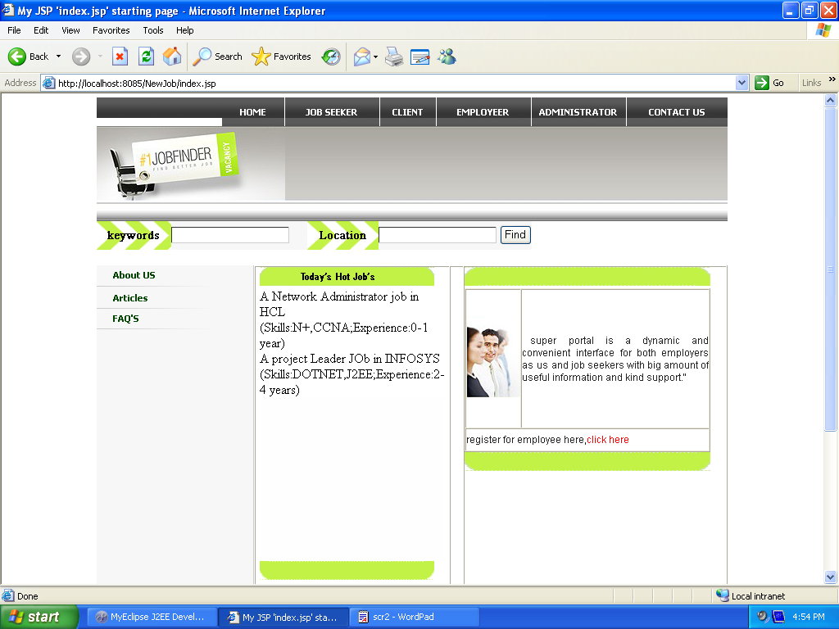

Job seeker new registration:

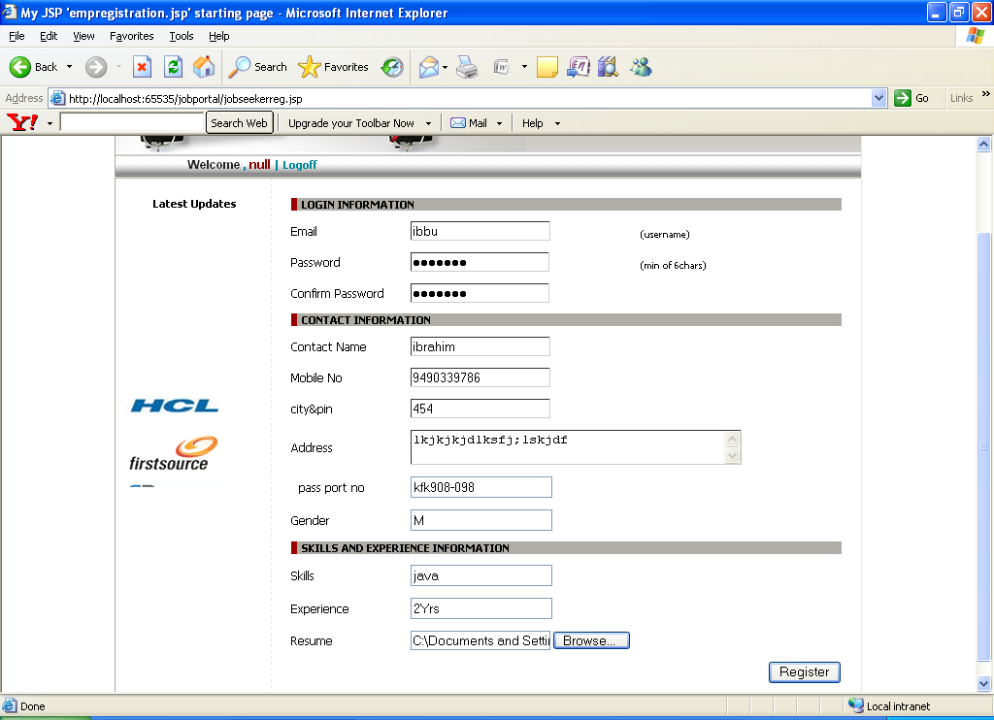

Job seeker Login:

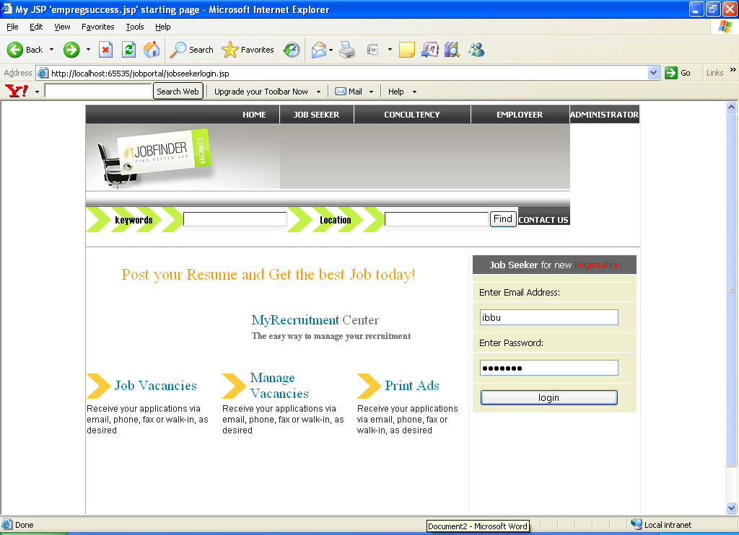

Job seeker module homepage:

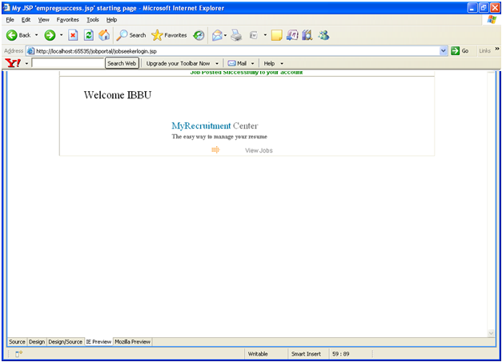

Employer New registration:

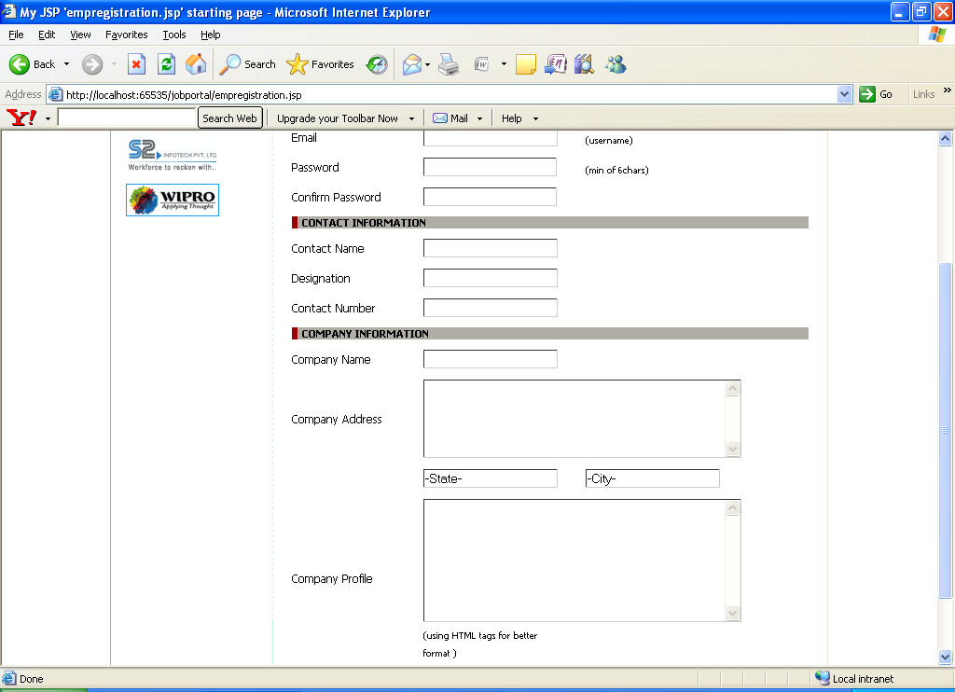

Employer Login:

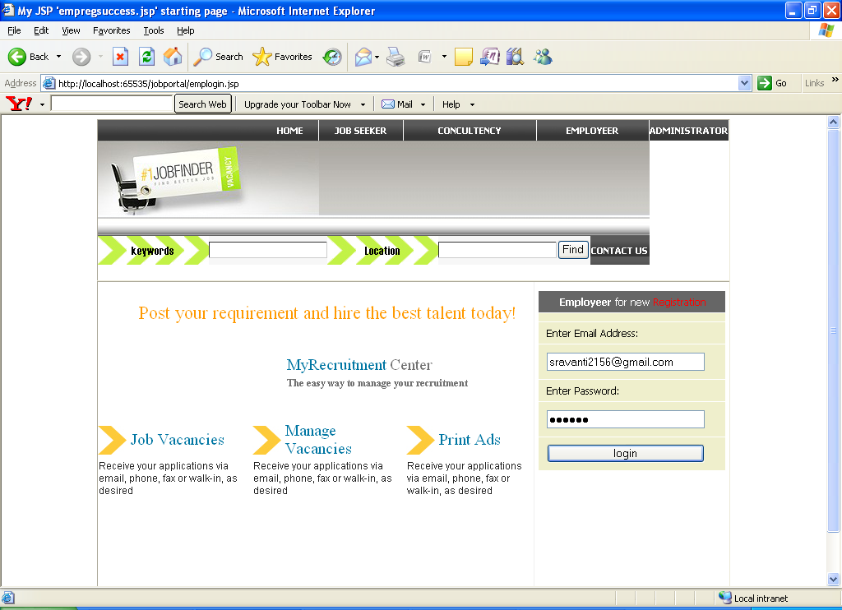

Employer module home page:

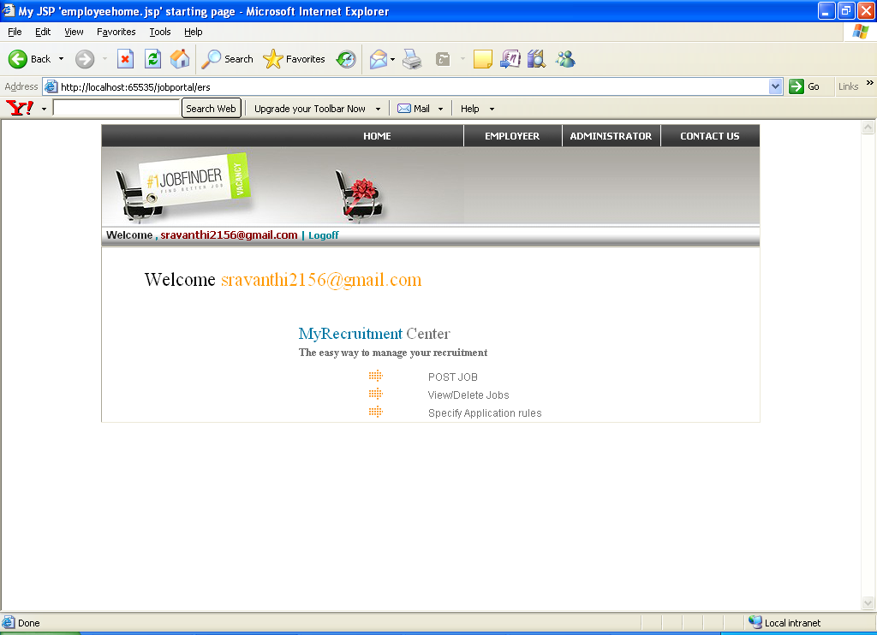

Posting the jobs:

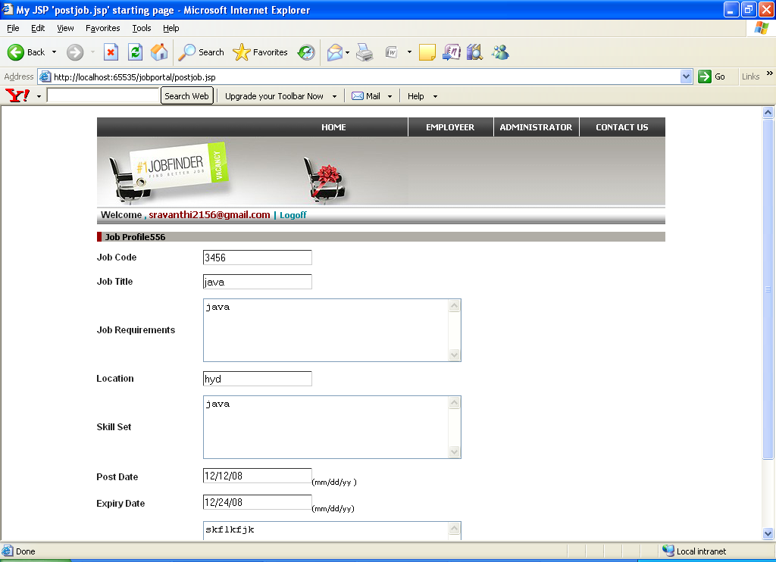

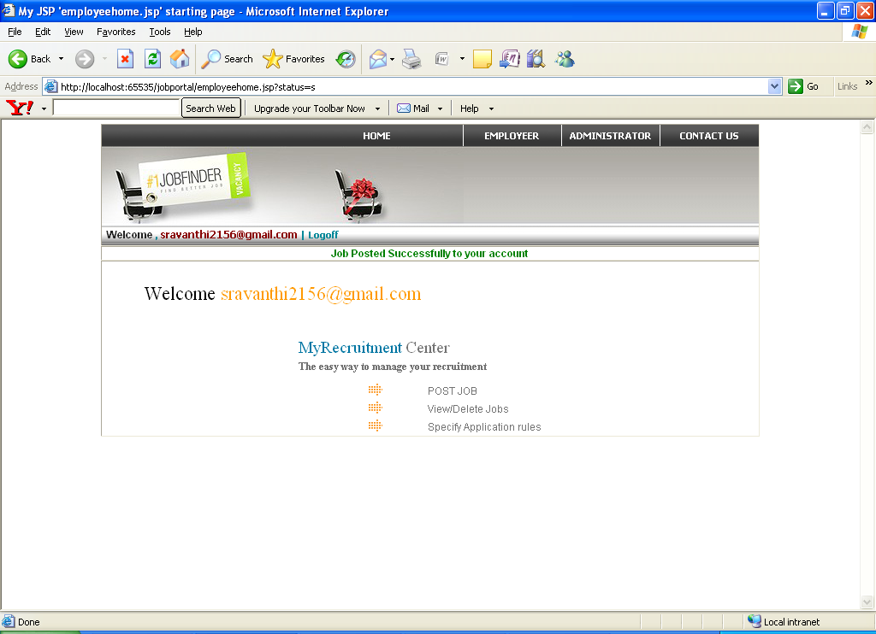

View or deleting the job profile:

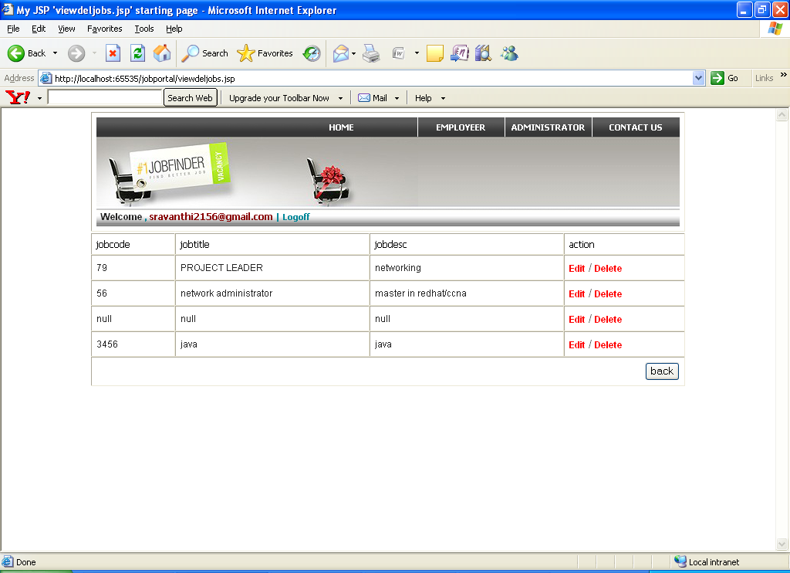

Updating job profile:

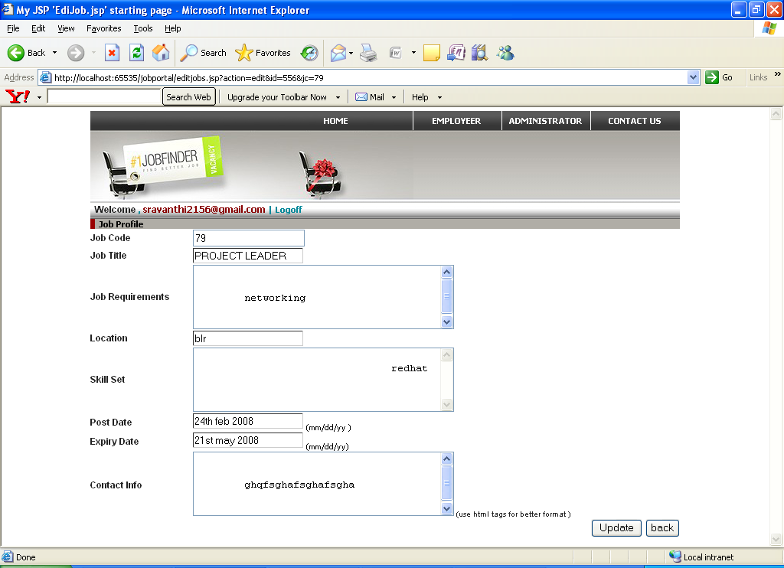

Deleting the job profile:

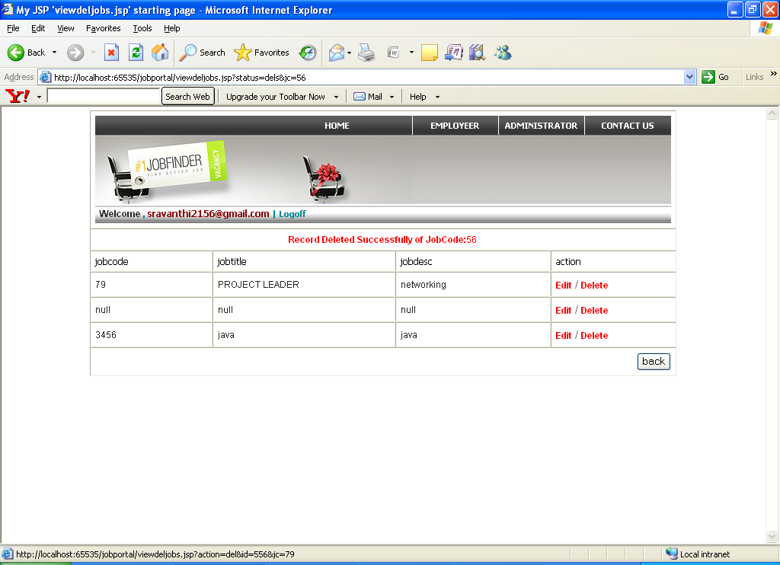

Logging off employer:

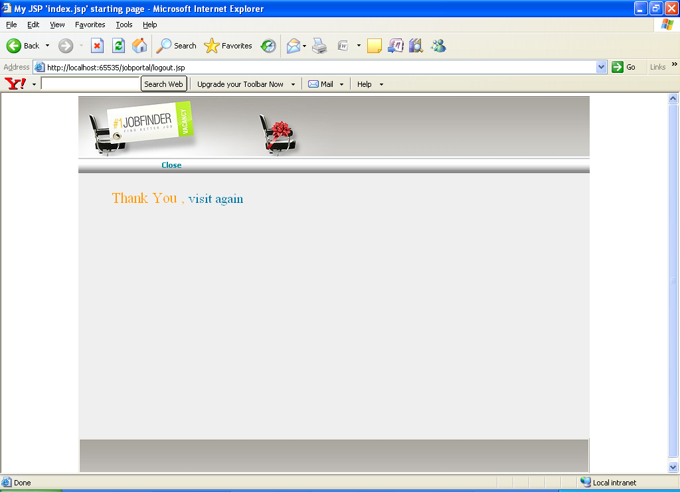

Administrator Login:

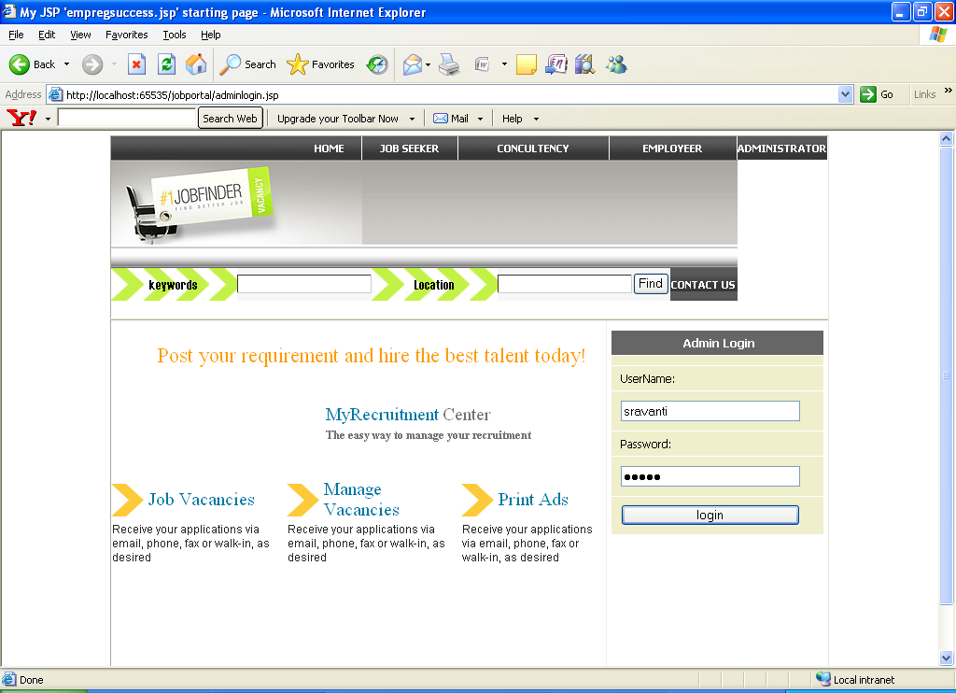

Administrator module homepage:

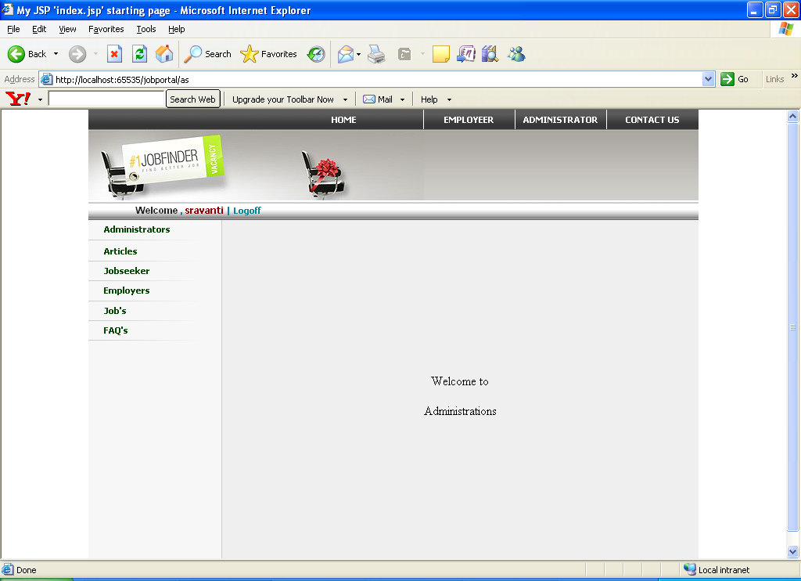

Administrator Details:

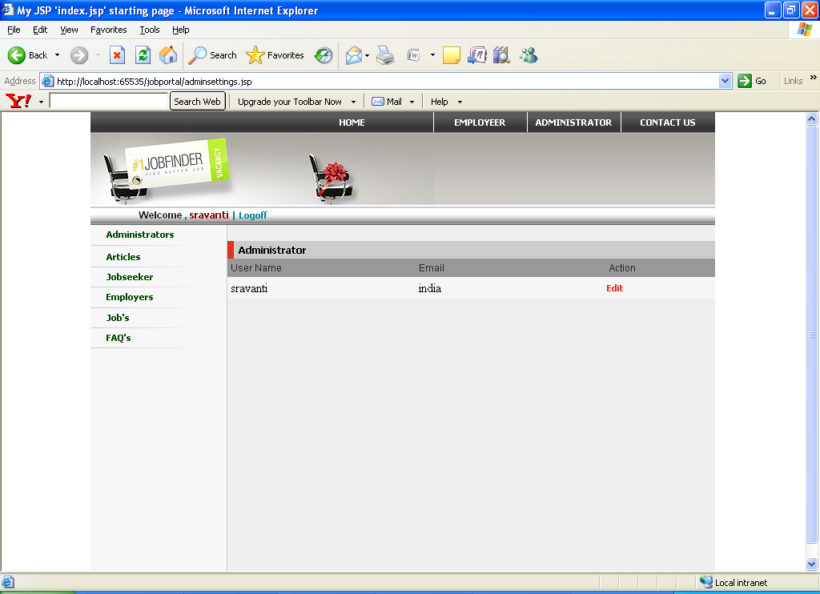

Posting Articles:

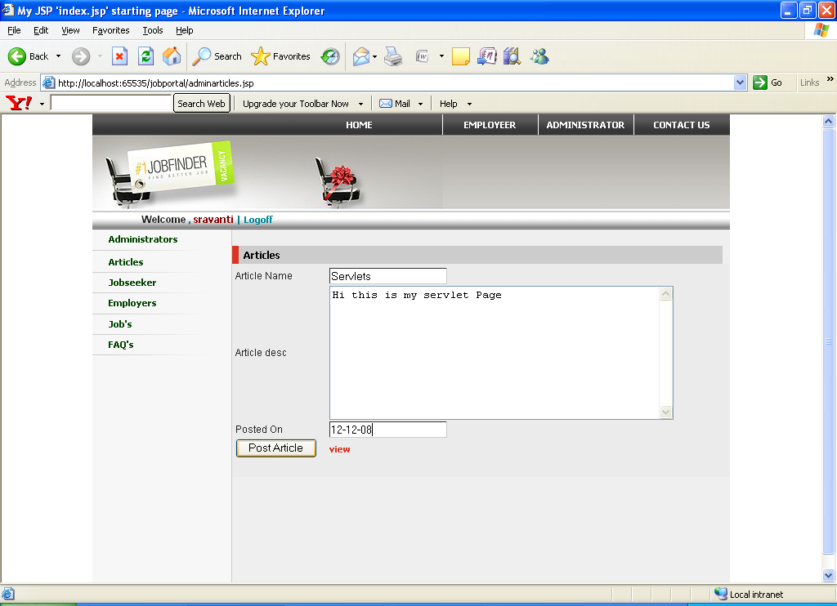

View Articles:

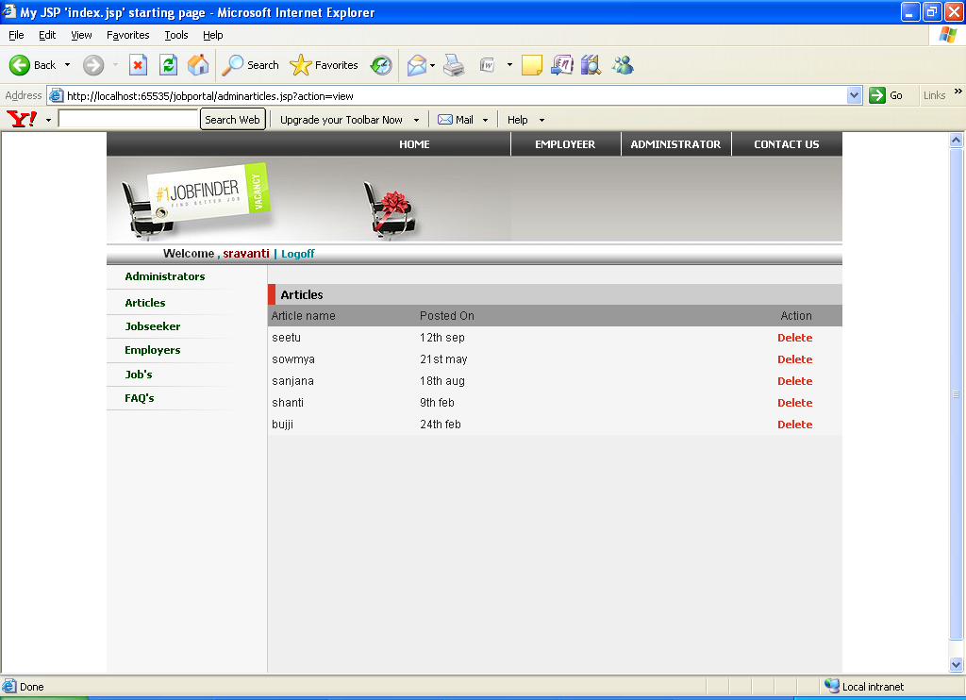

Deleting Articles:

Deleting Articles:

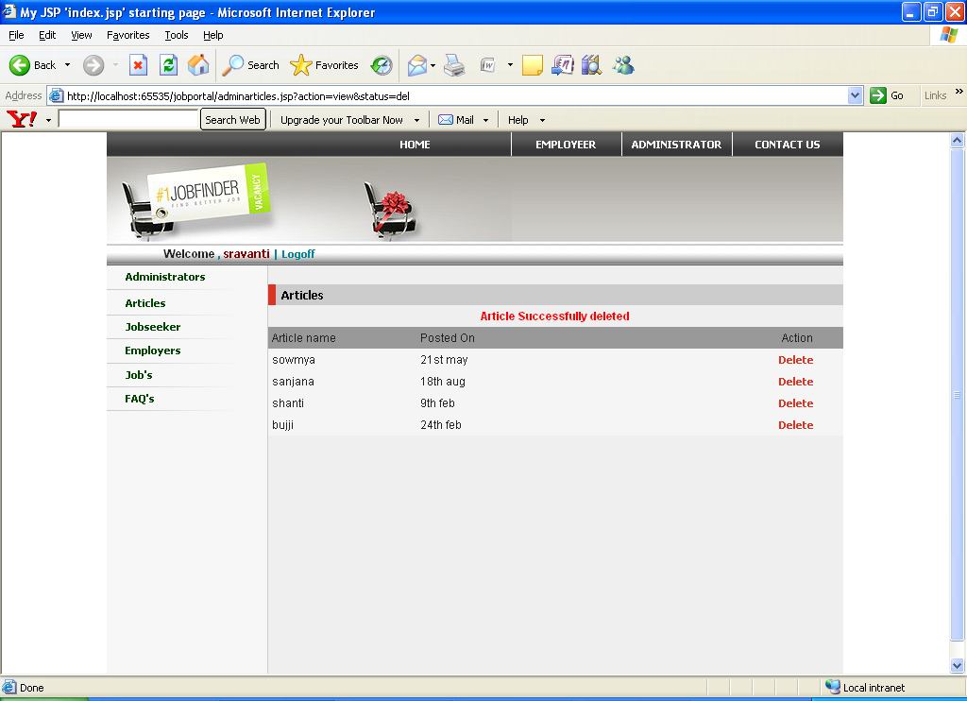

Job seeker details:

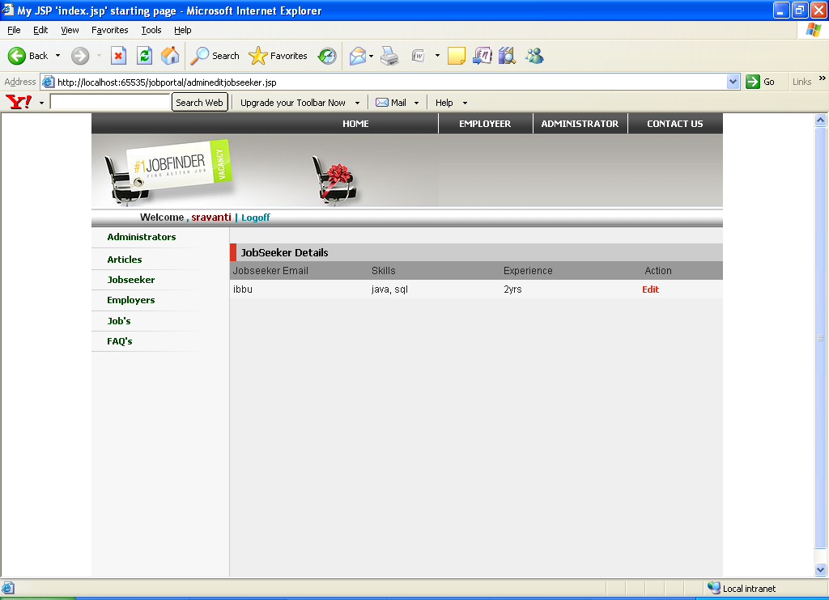

Employer Details:

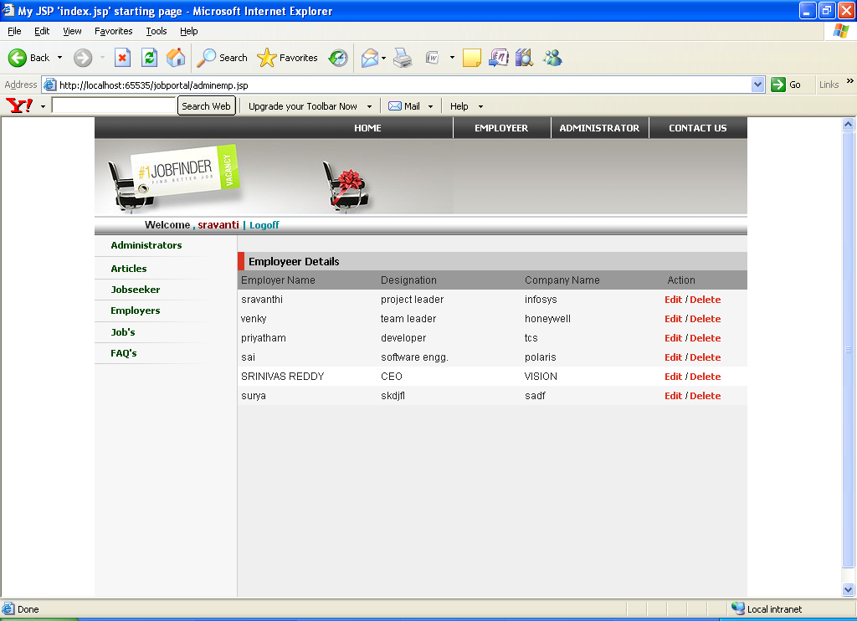

View jobs:

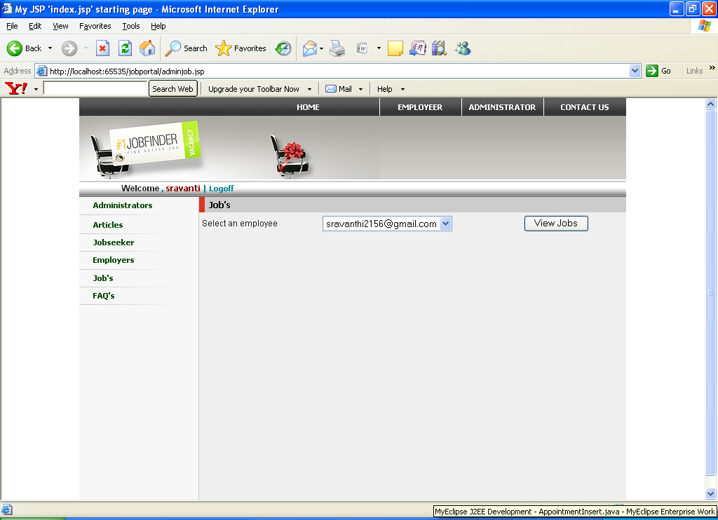

View jobs:

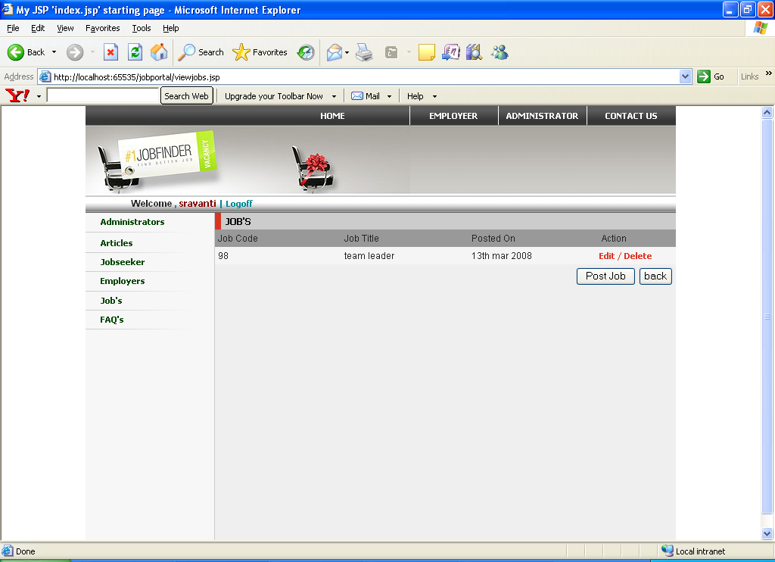

FAQ’S:

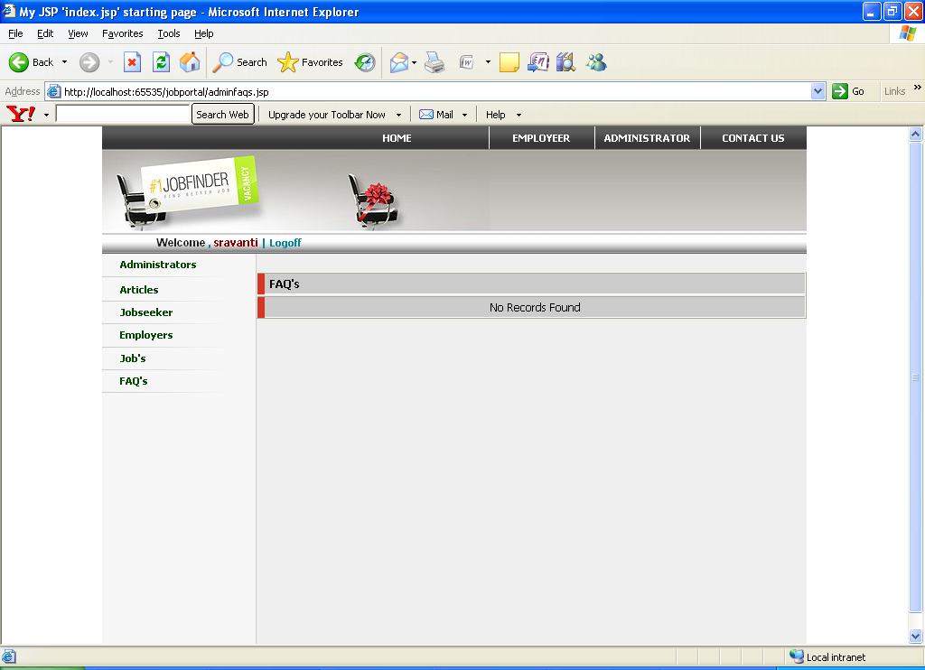

Logging off administrator:

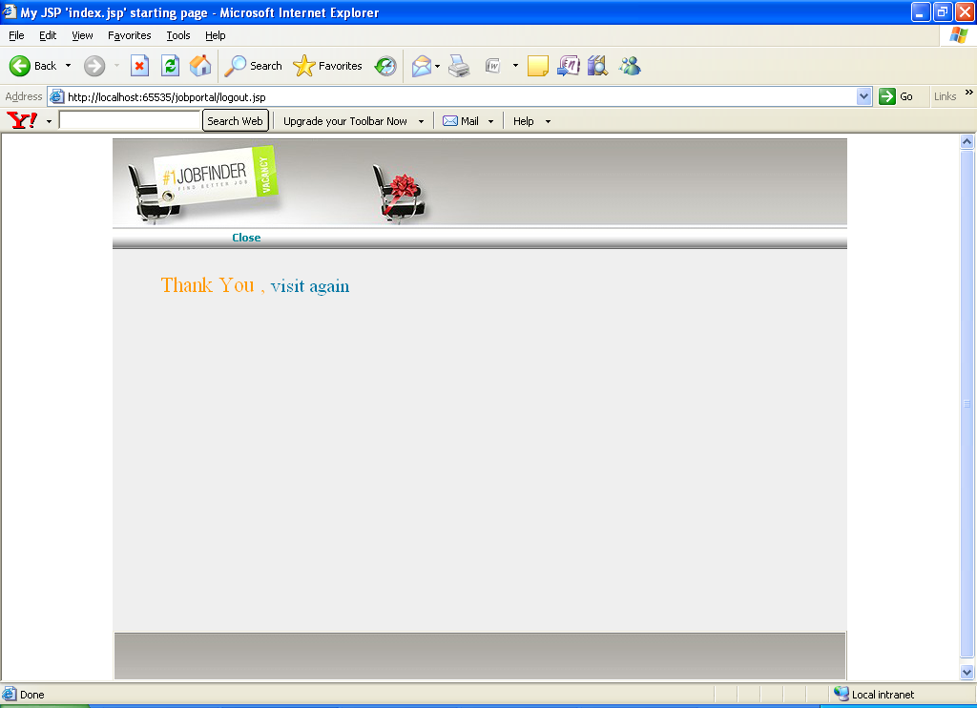

Searching Jobs:

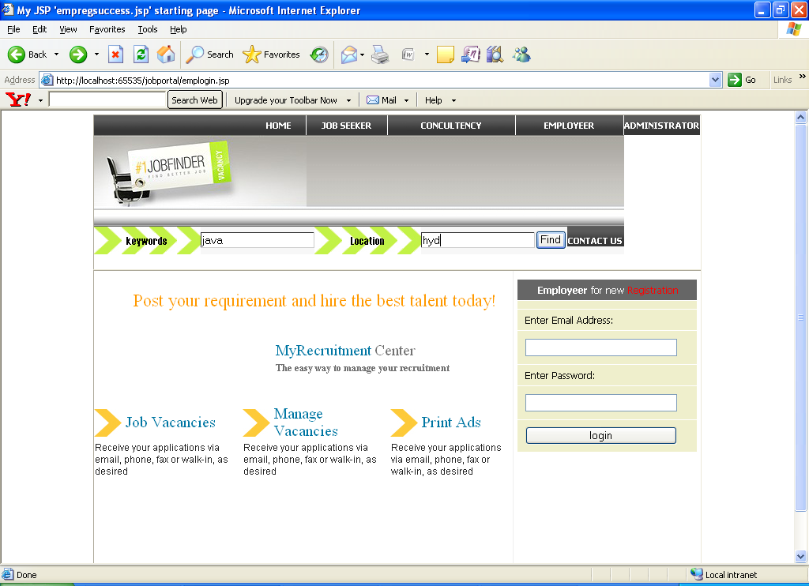

Job Search:

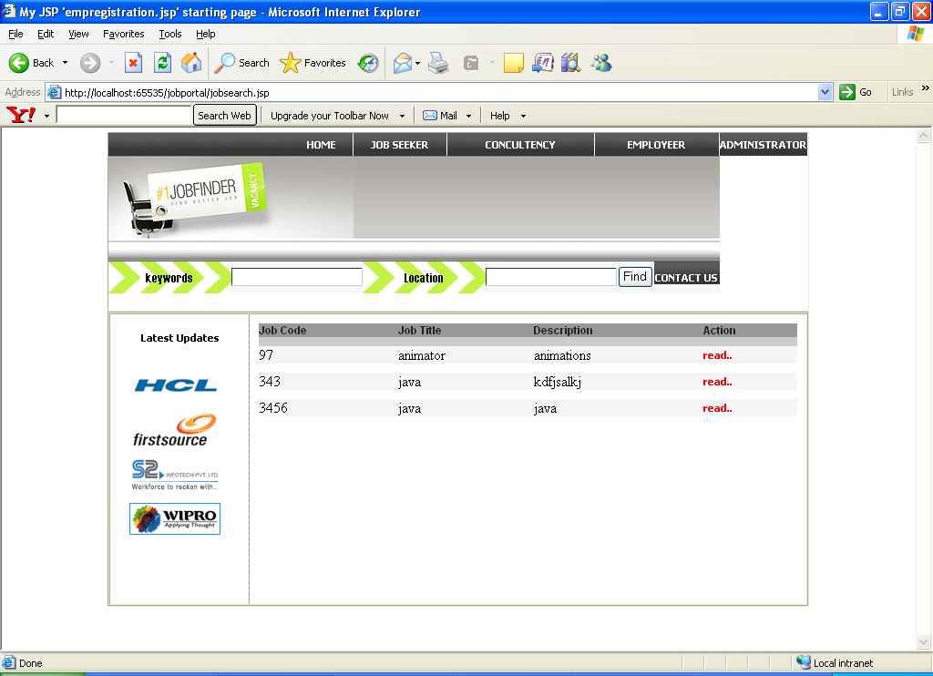

Reading Job profile:

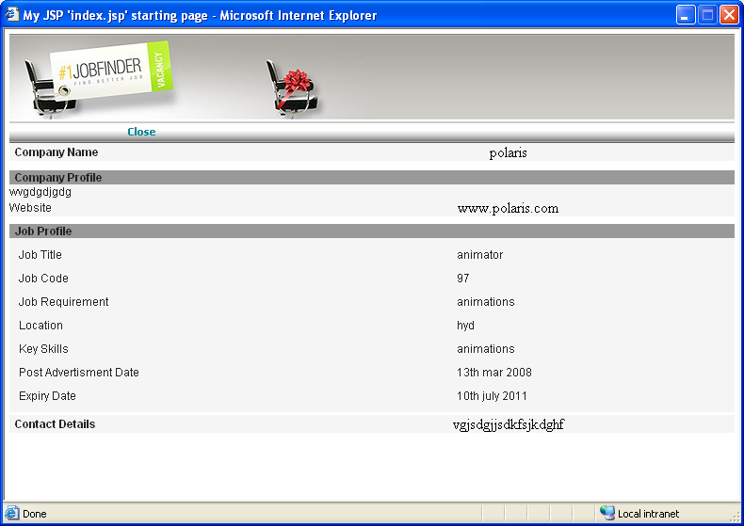

CONCLUSION

8. CONCLUSION AND ENHANCEMENTS

8.1 Conclusion

This system has been developed successfully incorporate all the requirements. Appropriate care has taken during database design maintain database integrity and to avoid redundancy of data. This site was developed in such a way that any further modifications needed can be easily done. User feels freely while using this site. In this all technical complexities are hidden. This site is a more user friendly.
The quality fusers like correctness, efficiency, usability, maintainability, portability, accuracy, errors, tolerance, expandability and communicatively all are successfully done.

8.2 Foreseeable enhancements

There is always a room for improvement in any software package, however good and efficient it may be. The important thing is that the website should be flexible enough for further modifications. Considering this important factor, the web site is designed in such a way that the provisions are given for further enhancements. At present this website provides all the information using static pages and reservation forms.
In future we can enhance our project by providing options like. Include many sites information.

BIBLIOGRAPHY

9. BIBLIOGRAPHY

JAVA SERVLETS ,; - TATA McGraw HILL
- Karl Moss

SOFTWARE ENGINEERING
A Practitioner's Approach
- McGraw-Hill Publications
- Roger S. Pressman.
Oracle-SQL & Pl/Sql Programming

- Evan Byross

[J2EE-Overview] - http://java.sun.com/j2ee/overview.html

[JS-NET] - http://developer.netscape.com/docs/manuals/communicator/jsref/contents.htm

[J2EE-Home] - http://java.sun.com/j2ee/

[J2EE-Components] - http://java.sun.com/j2ee/blueprints/platform_technologies/component/index.html

[SUN-Developer] - http://developer.java.sun.com/developer/

